www.buffalosoldiersresearchmuseum.org
Buffalo Soldiers Research Museum Newsletter
October 2007
Volume 5 - Issue 4
Published four times each year ~ January, April, July & October

Reunions – Buffalo Soldiers and More
Reflecting on our experience at the 133rd and 139th anniversary reunions of the 9th and 10th (Horse) Cavalry Association, we asked ourselves many questions. What is the purpose of a reunion? Why do we get together? How do we benefit? What did we learn? Who did we meet? Why bother to go?

Yes, the time and money spent to connect with these old soldiers is valuable and the reunions serve an important purpose. Each reunion provided a vast array of educational opportunities. We talked to World War 2 soldiers and attended a history seminar; we attended official parades and learned historical facts about military bases; we met and interacted with Buffalo Soldiers’ friends and family members; and we socialized in-town with locals as well as with others at the reunion.

Now, our focus turns to the educational component of reunions…. From planning one so that everyone gets the benefit of a satisfying experience to evaluating resources to make the event comfortable and affordable, we have started about 15 months in advance to try to get things in order. The Family Reunion Institute at www.temple.edu/fri/familyreunion has a detailed list to help with planning. Here are a few additional resources to consider:

Genealogy software ~ Information sites ~
Family Tree Maker www.Ancestry.com
Family Reunion www.aahgs.org
Online databases ~ www.freedmensbureau.com
www.Afrigeneas.org www.africanancestry.com
www.Familysearch.org www.africanheritage.com

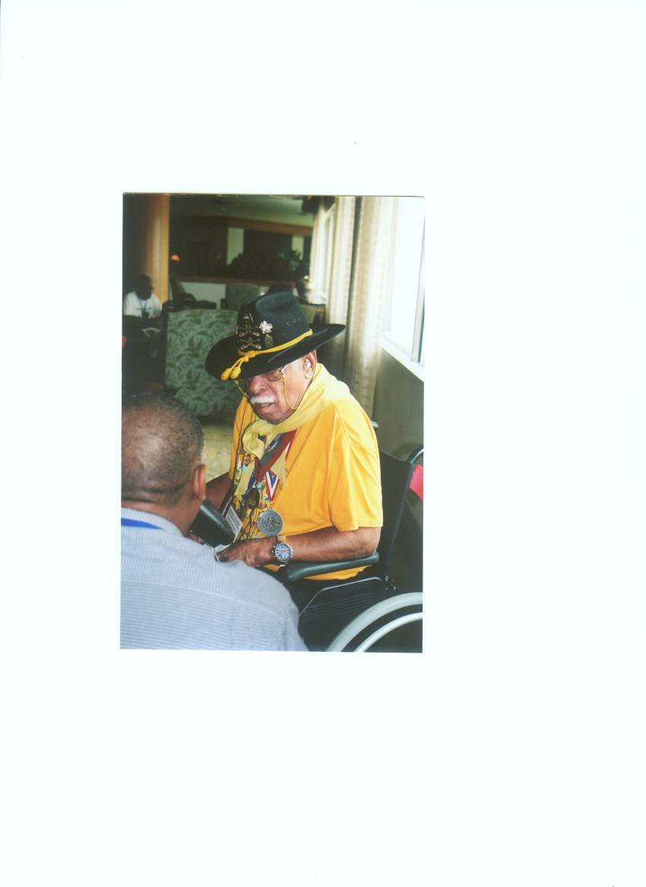
Many of these sites will help you reconstruct your bridge to the past. Consider an ancestral historical timeline that begins with the most recent migration north to south (1980- present), the civil rights movement (1954-1970), the Jim Crow era (1895-1954), and even the Civil War (1861-1865). And, don’t forget the value of oral history interviews. At the 2005 Buffalo Soldiers reunion, we arrived with a notepad, pens, and a tape recorder. Each interview began with open-ended questions that elicited their military stories. We asked questions and looked for feelings and descriptions. We learned to be creative listeners and did not dominate the conversation. And, when our conversations ended, we took photos and thanked them for sharing their memories with us. Here are a few photos from the interviews and the reunion events in Tampa.
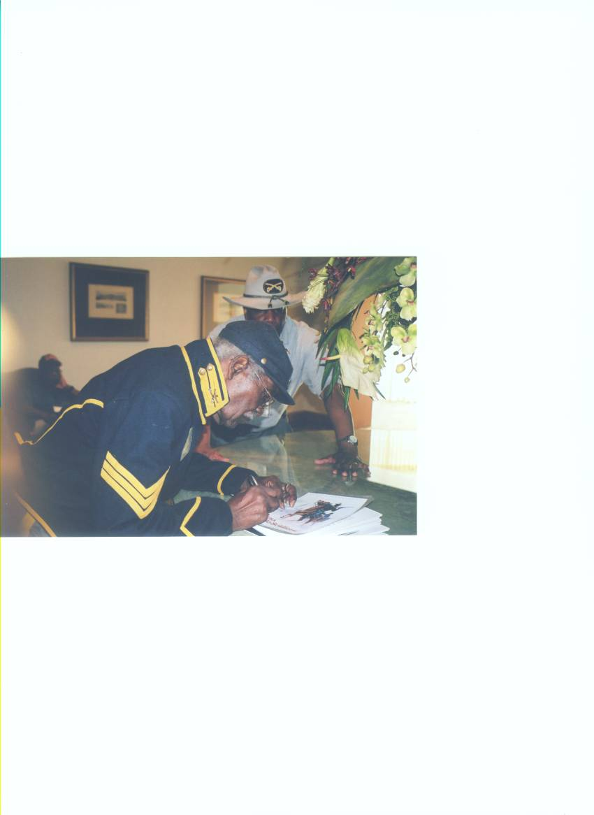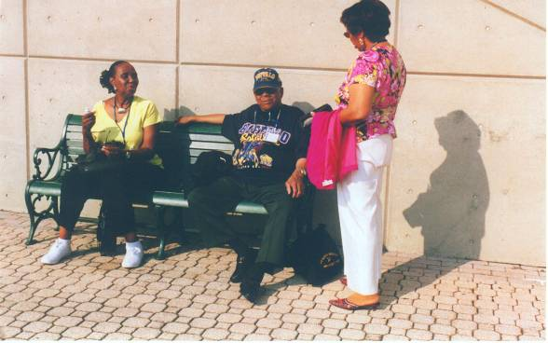

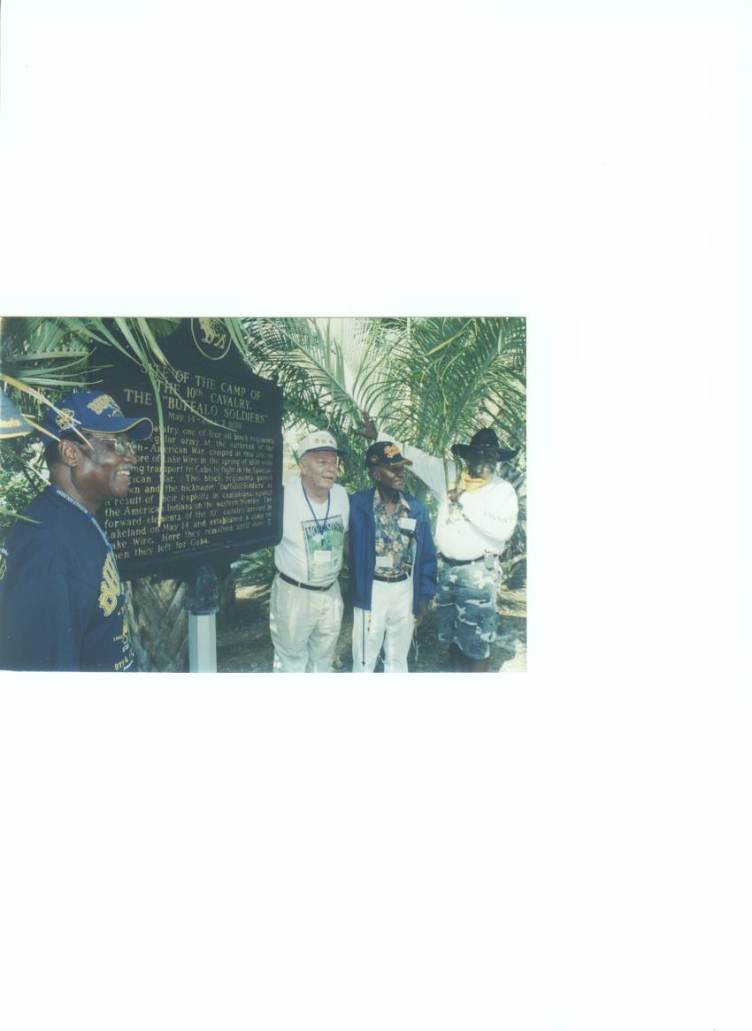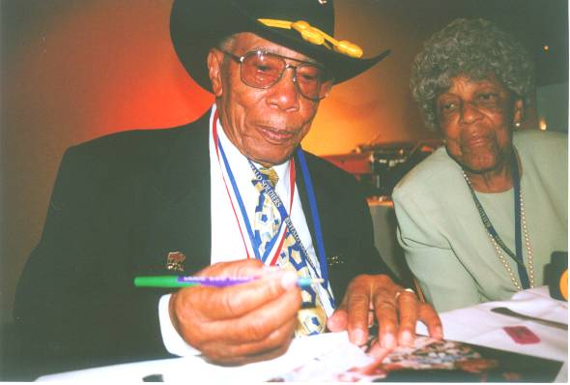

~ Celebrating Your Family Health Heritage ~
Family health heritage is a record of important medical information about our ancestors and relatives. Many of the factors that determine our health or illnesses were inherited from our ancestors. Creating a family health heritage history can be beneficial in providing an assessment of our medical history. Researching and documenting family health heritage can also assist in interpreting patterns of health, illness, and genetic traits of our ancestors. Understanding our risk for developing diseases is an important reason to learn more about family health history. By knowing our risk factors, we can make informed decisions about prevention

What should be included? First, record you own medical and health facts. Then, go back one generation at a time. Record information on all family members, including the age at which they were first diagnosed, their treatment, and any surgery procedures. A comprehensive list of health conditions should include heart disease, cancer, diabetes, asthma, high blood pressure, stroke, kidney disease, learning disabilities, as well as alcoholism. On the other hand, it is vitally important to respect the privacy of all family members. This may make it difficult to get accurate information. Just beware!

Sources of information can include medical records and the recollections of living relatives. For deceased ancestors, visit your local state health department to obtain copies of death certificates. A dearth certificate will list the cause of death and the age of your relative. Other sources may include military records, family bibles, pension documents, census records, and obituaries.

One of the most important things parents can give their children is their family ancestral roots. When we understand where we came from, we can stand tall and proud. We stand on the backs of our ancestors - those who came before us who gave us the foundation to build our lives.

Our past, our stories, our health, and our future – all depend on the accuracy of the information we collect.
~ DNA Database Helps Identify Your African Ancestry ~
African Ancestry, Inc. (www.africanancestry.com) has become the exclusive licensee of a prominent genetic researcher’s database of genetic lineages from Africa. This company, based in Washington DC, is selling DNA-based genealogy tests to anyone who wishes to genetically determine where in Africa his African ancestors came from. The test does not involve needles or blood. Laboratory scientists compare cells swabbed from the inside of your cheek with 22,000 units of genetic information (maternal and paternal lineages representing over 30 countries and 135 ethnic groups). Two tests are offered – MatriClan test of maternal DNA inherited from your mother and PatriClan test of paternal DNA inherited from your father. Each test cost $349.
This technology is being embraced by family reunions to add new information to their celebrations. Some relatives have traced the African ancestry of as many as eight of their family’s lineages. This means that they have located where all eight of their great-grandparents’ African origins began on the continent! For details call 202/723-0900 or visit their website.

Information about family reunions was taken from materials provided at a Legacy workshop sponsored by the Afro-American Historical and Genealogical Society, Inc. The Afro-American Historical and Genealogical Society, Inc (AAHGS) strives to preserve African ancestored family history, genealogy, and cultural diversity by teaching research techniques and disseminating information throughout the community. Their primary goals are to promote scholarly research, provide resources for historical and genealogical studies, create a network of persons with similar interests, and assist members in documenting their histories.
The Indiana African American Genealogical Group began in 1999 for family researchers of all experience and interest levels. Their vision is to discover and document the African ancestry in each family lives through each person with whom they share, inform, and encourage – everyone they touch. Membership is $25 for adults and $15 for youth. Contact them at: IAAGG, PO Box 1811, Indianapolis, IN 46206-1811 or inplsagenegroup@yahoo.com

Buffalo Soldiers Research Museum
P.O. Box 531187
Indianapolis, IN 46253

www.buffalosoldiersresearchmuseum.org

