_______________________________________________________________________________________________________________
Buffalo Soldiers Research Museum Newsletter
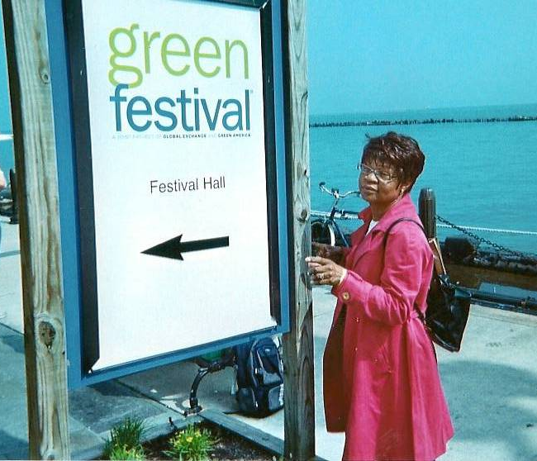
***Goes Green***
July 2010
Volume 8 - Issue 3
Published four times each year ~ January, April, July & October

Our Going Green Efforts
George Hicks, III
Carmon W. Hicks

We are tenants of the Almighty
Entrusted with a portion of His earth
To dress and keep
And pass on to the next generation
When evening comes and we must fall asleep.
Louisiana Dunn Thomas
Farm tenant mother
Greene County, GA (Schor, 1980)

If anyone were to ask “what forms the common core of our African American cultural heritage?” the answer lies in the shared beliefs of thrift, frugality, and hard work. The women and the men who grew the grain, food, and fiber which fed and clothed others from the earliest times until today provided a great gift that continues to spread throughout the world. The role of the black farmer and his family are significantly related to our history and our future. Black agricultural education was established at the 1890 land grant institutions and formed a foundation for blacks interested in higher education. Most of these institutions possessed a college farm, instruction in agriculture and in teaching moral education. Their focus was on the small farmer and his family and began training black farmers and homemakers (Weaver, 1986).

Every generation has advanced our progress in agriculture, education, and environmental issues. Consider the food, household items, and clothing that slaves received from their owners and shared among family and friends. Think about the recycled uniforms, hats, boots and horses that Buffalo Soldier troops received during their service to the U.S. We are fortunate to be in the position to carry on the work regardless of impending obstacles. In today’s environment, there are no guarantees regarding sunlight, rain, drought, and unpredictable weather conditions when tending a garden. And, environmentally, we are bombarded with disposable items that we conveniently put in the trash rather than reuse or recycle.

How can urban farming reconnect us to the earth? Urbanization and integration have moved most African Americans away from agriculture. We are running in all directions. Living in neighborhoods made of cement with no trees, flowers, or vegetables. We often align the green economy or environmentalism with upper-middle class whites or socially conscious professionals with money to burn. But historically, we are culturally tied to the soil – as slaves, sharecroppers, and subsistence farmers. Recent initiatives have helped African Americans re-focus on the earth. A black environmentalist in Chicago turned her home and several vacant lots into urban farm sites. Rooftop, hydroponic or community gardens offer a good financial payoff for urban farmers. One urban farm in Milwaukee offers fresh food grown cheaper, compost piles, greenhouses, and farm animals while earning $220,000 in one year. In New York City, there are more people participating in the green cart program which allows more permits for fresh food vendors that focus on underserved communities. Opportunities abound to bring black people and green markets together (Olopade, 2009).

We enjoyed Chicago’s Green Festival held at the Navy Pier on May 22-23, 2010 (photo on previous page). Since we arrived on the Megabus (visit www.megabus.com), our admission was half price. There were more than 200 services and vendors – all sharing ideas about how to go green. We enjoyed a Jamaican vegetarian lunch, listened to several speakers who later signed their books, and learned about fair trade, solar panels, and acupuncture. We spotted the folks from www.wefarmamerica.com and thanked them for their advice for building a raised garden. We learned a lot from their website. Unfortunately, they only assist people who live in Illinois but they were proud that we were able to use their advice.

Winter Preparation Essentials for Your Garden Plan -

Gardening is a yearlong adventure. During the winter, decide how you are going to start your plants and enjoy eating a variety of fruits and vegetables. By sampling all types of garden items, you can eliminate wasted garden space for vegetables you may not want. A big part of gardening is enjoying what you grow, so don’t waste time tending to items that will rot away. This step will make you familiar with the times when specific foods are in season. For items you want to grow, ask - is there good sunlight? Can you grow an adequate amount for several meals? When is the growing season? What are the potential pests and how are they controlled? Keep in mind that your garden requires time and money so it is important to consider how much you will spend, consume, and share.

Next, determine whether you will propagate your own seeds or get plant cuttings from your local garden center. If you decide to start your plants indoors, the soil needs good moisture, sunlight, and a warm location. Read the seed packages to help you determine the best strategies (Grabow, 2010).

Six Tips to Help Get Your Garden Started –

- Identify a plot of land for your urban garden and have the soil tested at a local lab for possible contaminants. A raised garden reduces the chances of plants absorbing chemicals and plants with flowers (like tomatoes, peppers, and green beans) absorb fewer chemicals.
- Start small and grow something you enjoy.
- Use local plant materials started from seed or seed transplants.
- Add compost and aged manure to the soil. This adds to the garden’s sustainability and produces healthier soil that is more disease resistant.
- Note your successful crops. Try new varieties that suit your soil and sunlight.
- Extend the growing season with cool weather crops like cabbage, collards, kale, and bok choy (Wezensky, 2010).

Our Efforts

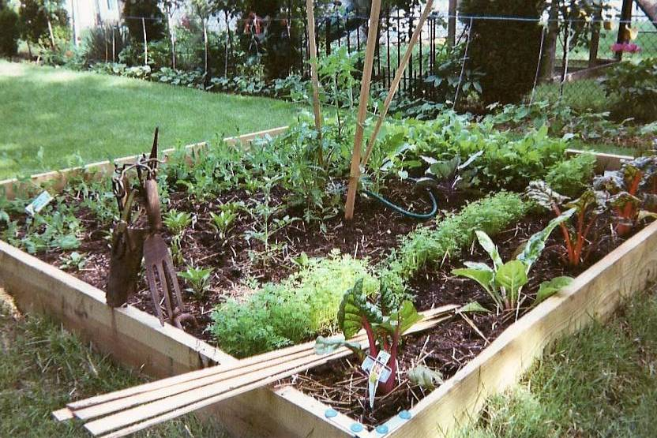
In late April, we attended a program called “Gestalt Gardening” at the Indianapolis Museum of Art. The lecturer talked about ways to create more gardens and less grass; he provided a slideshow with creative strategies using recycled items for yard sculptures. He illustrated beautiful yards with colorful cut glass and focused on raised gardens.

George immediately went to work in our backyard. Oh so much grass! He removed grass and used 10’ x 10’ boards to create frames for two raised gardens. They required lots of soil so compost was added to the many bags of top soil. An irrigation system using a watering hose was installed underground.

For details on the architecture of a raised garden, visit www.wefarmamerica.com (mentioned earlier). Their gardening goals are to test, build, install, instruct and grow. You can purchase backyard garden kits and other supplies from them. It is an informative website especially for those who need basic information for getting started.

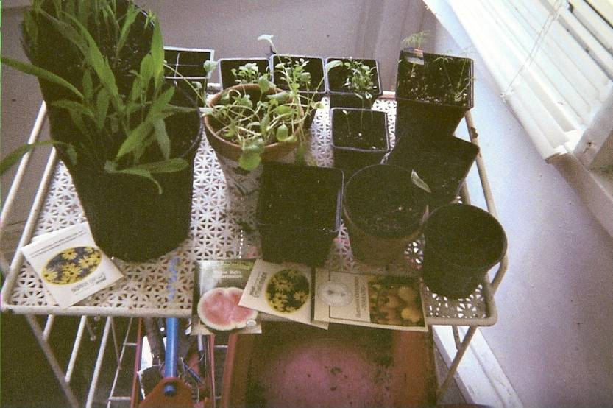
While George developed the raised gardens, I started a variety of vegetables, herbs, and flowers from seeds. I planted squash, radish, carrot, okra, and tomato seeds. Later, I started a variety of beans, Italian parsley, cilantro, four o’clocks, verbena, and black-eyed susans. We bought a small seed starter from Worm’s Way near Bloomington, IN. It held approximately 60 plants in 1” x 1” squares. The starter kit contained a plastic cover to keep the seeds moist. The tray with lid was placed in a south window near the water heater. Most of the seeds successfully sprouted and when the plants got too big for the tray, they were moved to bigger containers that we recycled from store-bought plants (photo to the right). Eventually we moved each group of plants to the raised beds and in other parts of the yard.

One raised garden (above) contains peas, radishes, tomatoes, carrots, peppers, cabbage and Swiss chard. The second garden contains broccoli, carrots, tomatoes, purple and green cabbage, and okra. In addition, rosemary and sage are growing big in this bed. It’s important to think about how to arrange each vegetable so they can be easily harvested. Tall plants (like tomatoes) are planted near the center – note the tall plant sticks (in the garden photo) are used to keep the tomatoes off the ground.

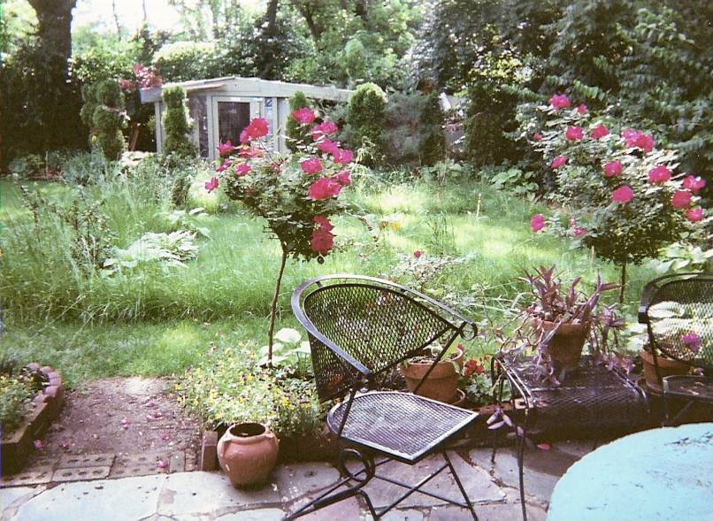
We always start our spring flowering season with pansies –they can thrive when snow comes in late March or early April. By early May, our rose bushes were in full bloom and surrounded by small purple and yellow pansies. This backyard view, from the Buffalo Soldiers Research Museum, has many geraniums, sedum, hostas, and a few potted plants that survived the winter. We call it our Mediterranean garden (at left). Beyond the rose bushes, is our hosta garden surrounded by a taller grade of grass. Beyond the hosta garden sits our greenhouse. It has a skylight roof that houses starter plants waiting for a place in one of the gardens.

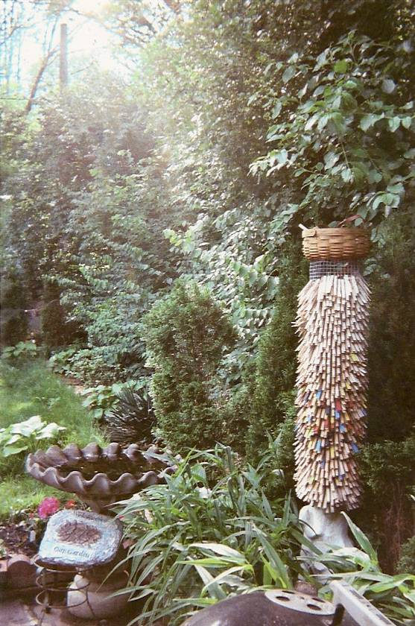
To the right of the rose bushes is a stone bird bath (photo at right) that keeps our neighborhood robins, cardinals, and black birds busy singing their “thanks” when they bathe or take a drink. We recently spotted a woodpecker and occasionally see bluebirds that shine with an iridescent turquoise. George’s tall clothes pin sculpture adds colorful art to the greenery. The clothes pins are attached to a wire that’s tube-shaped. This garden gets indirect sunlight from the north and when the sun sets in the west (as you can see in the photo), the flowers stand up and smile.

On the south side of the yard, the Bradford pear trees are growing tall. They provide a wonderful spray of white flowers in April and transform into a natural privacy fence with small evergreens at their base. Fences make good neighbors…

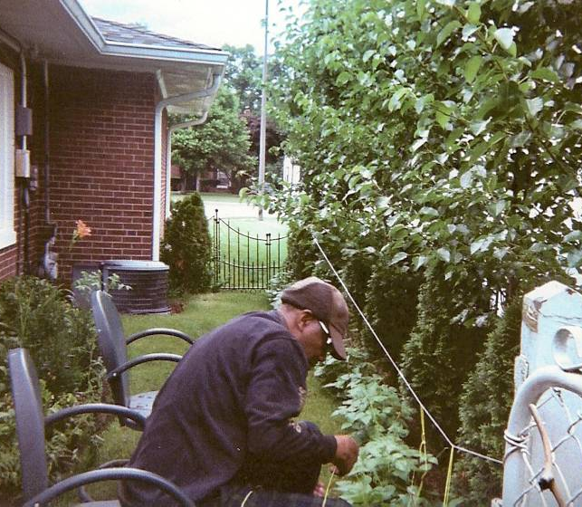
We decided to layer the garden so pole beans, okra, cucumbers, and a few flowers - four o’clocks are planted in front of the trees. George ties the pole beans to a thin natural rope to make it easy when we pick beans. A few days ago, we picked enough green beans for a meal. The slender beans often hide under the big leaves so the bean-picker must develop an eye for finding the beans. What a treat!

Behind George, you will discover day lilies, cherry tomatoes, kale and turnip greens, Vidalia onions, squash, and a huge purple mum. This flower is noteworthy since it was given as a gift a few years ago and it continues to come back every year – bigger ad better. We made an effort to add a few flowers where ever space permits. The flowers add color especially when the garden only seems to have many shades of green.

Results!

Spring onions have been a wonderful treat as we watch and wait on our harvest. The trick is to eat when vegetable get ripe. We are enjoying green beans and peas. Radishes are ready and small green tomatoes are on the vine. In June, about 9 inches of rain fell so some of the vegetables like squash and okra seem to be off to a slow start. We know that there are no guarantees. Stay tuned four our fall green issue…

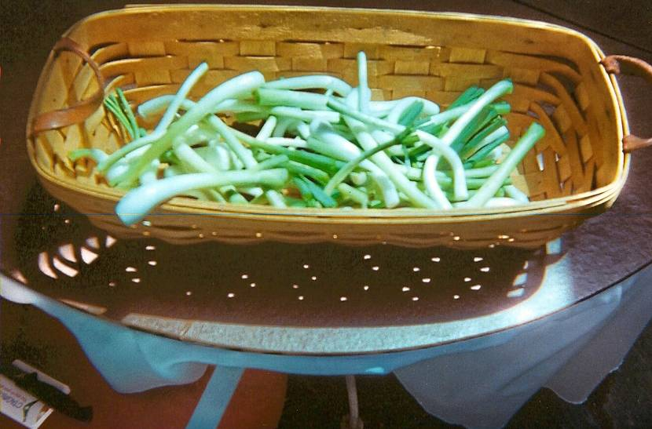

Last Minute Thoughts

If seeding, planting, weeding, watering, picking, and eating fresh vegetables sounds like a chore, here are several strategies for incorporating other green strategies in your life –

- Recycle EVERYTHING. Challenge yourself to double your recycling and halve your trash (www.nature.org, 2010).
- Resolve to lose 5,000 pounds off your carbon footprint. How can you determine your carbon footprint? Commuting, sheltering our families, and the foods we eat contribute to the greenhouse gas emissions that are creating climate change. The choices we make at home, when we travel, and products that we buy and throw away all influence our carbon footprint. Visit the Nature Conservancy’s website (www.nature.org) to measure your impact on the climate.
- Instead of driving your car, walk, bike or take the bus. I started riding the bus to work this summer. It has been an amazing observation as I note the drivers on the road – one person in each car, SUV, or van. Each day, I can count on one hand the number of vehicles with more than one person. Clearly, nobody is car-pooling. On the other hand, I am pleasantly surprised when I jump on the bus and it is packed with commuters – black and white, young and old, professional and hip-hop. I feel right at home.
- Stop drinking from plastic bottles. Get a reusable water bottle and drink more water.
- Buy local food and drinks. Consider a vegetarian meal at least once a week.
- Lower your thermostat in the winter and raise it in the summer. Add layers of clothes and keep a blanket handy. Use fans rather than air conditioning. Save money and the environment.
- Join an environmentally friendly organization. Some such as the Sierra Club and Slow Cook have fun meetings. Others work to educate and encourage participation in environmental policies (Jenkins, 2010).

There’s something for everyone. So, get started!

References used for our first going green issue -

Grabow, C. (Jan. 2010). So you want to grow your own food? Winter preparation essentials. Natural Awakenings: Greater Cincinnati Edition. Nacincin.com: Cincinnati, OH.

Jenkins, L. (Jan/Feb, 2010) Old resolutions go green. Indiana Living Green magazine: Zionsville, IN.

Olopade, Dayo (April 22, 2009). Black folks, green thumbs. Retrieved on January 27, 2010 from www.theroot.com

Schor, Joel. (Feb. 1980). Black women in American agriculture. Unpublished paper.

The nature conservancy. Retrieved from http:// www.nature.org on June 11, 2010.

Weaver, C . (Fall 1986). Women of the soil: Cotton cultivation and the role of black women from slavery to today. AASP 428 – The Black Woman in America at the University of Maryland, College Park, MD.

Wezensky, D. (April 2010). Good growing: Doing it yourself. Indianapolis Magazine: Indianapolis, IN

Raised gardens. Retrieved from www.wefarmamerica.com on June 28, 2010.

For more information, contact the

Buffalo Soldiers Research Museum
P.O. Box 531187
Indianapolis, IN 46253-1187
georgehicks@comcast.net

