www.buffalosoldiersresearchmuseum.org
Buffalo Soldiers Research Museum Newsletter
July 2005
Volume 3 - Issue 3
Published four times each year ~ January, April, July & October

Going to Tampa with the Buffalo Soldiers!
The 139th Anniversary Reunion of the 9th & 10th (Horse) Cavalry Association will be held in Tampa, FL from July 27-31, 2005. The Woods & Wanton Chapter of the 9th & 10th (Horse) Cavalry Association will host the event. This is the first time that the Reunion will be held in Florida. The Buffalo Soldiers have a historical record in Tampa. They arrived in the bay area on May 2, 1898. The 9th Cavalry was stationed in Port Tampa & Picnic Island & the 24th & 25th Infantry were in Tampa Heights & Ybor City. The 10th Cavalry camped in Lakeland but by June 7, 1898, moved to West Tampa. From there, these units were shipped to Cuba to fight in the Spanish American War.

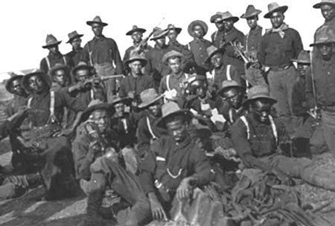
10th Cavalry Troopers - Spanish American War
Augustus Walley standing on back row with bandana was a Medal of Honor recipient

Events planned for the Anniversary Reunion include a historical seminar; a theater production; a historical tour to Lakeland, Ybor City & Fort DeSoto Park; a dinner cruise, & more. A day in Orlando enjoying the many shopping malls and outlets has been planned, also. Contact Trooper Celeste Gibbons-Peoples, P.O. Box 76582, Tampa, FL 33675-1585 for more information. We look forward to seeing you there!
Trooper George Hicks, III
Carmon Weaver Hicks
BSRM researchers
Landmark Travel Guide

On our way to Tampa, we plan to visit African American historical sites and note linkages to the Buffalo Soldiers. Sometimes it is just the timeframe that connects but it helps to know about other events that were happening around the United States while these soldiers were proudly serving our country. Our landmark travel location is Alabama.

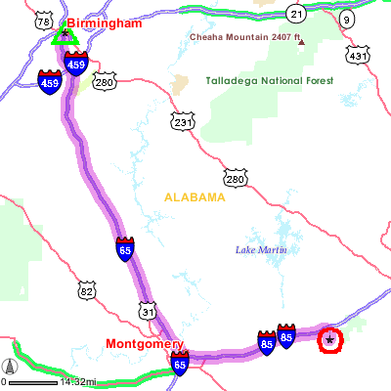
Birmingham, AL is located 145 miles west of Atlanta and 600 miles from Tampa. It is home to the Birmingham Civil Rights Institute, established in 1993, which tells the story about the Civil Rights movement through a variety of multi-media exhibits. The tour begins with a 12-minute video about the history of the city from 1871 through the1920s. The Barriers Gallery highlights life for blacks in Birmingham during the post-war era. The Confrontation Gallery has images of a KKK rally with voices reflecting the attitudes of the time. The Movement Gallery examines the Civil Rights movement with a 12-screen video wall that studies voting rights, slavery, Jim Crow laws, and the Birmingham jail where Martin Luther King, Jr wrote his memorable letters. King’s voice can be heard reading the letters. The Human Rights Gallery offers an international focus on human rights with information on ways each of us can make a difference.

From Birmingham, we will travel approximately 130 miles south and east to Tuskegee (note the circled star to the right of Montgomery). The George Washington Carver Museum is located on the campus of Tuskegee Institute. The museum focuses on Dr. Carver’s career in agriculture and chemistry. Exhibits include “The Tuskegee Album” depicting the development and growth of Tuskegee Institute as well as films about the lives of Booker T. Washington and George Washington Carver.

Booker T. Washington built his first home in 1899 called the Oaks. The house is adjacent to the campus. Built of Tuskegee bricks made by students and faculty, it reflects the broad interests of the Washington family and is furnished with original furniture and personal effects.

The Tuskegee Airmen National Historic site is being organized at Moton Field and will be dedicated to the African American flyers of World War II. The Tuskegee Institute National Historic Site includes information about the outstanding performance of the 15,000 men and women who accepted the challenge to join the Air Force from 1942-46. Admission is free and is open from 9 am to 4 pm daily.

Reflections
In 1980’s while assigned to the White House Transportation Agency in Washington DC, I discovered the Buffalo Soldiers’ story. Colon Powel was assigned to the National Security Office; occasionally, he talked to the enlisted soldiers in our agency about the role the Buffalo Soldiers played in US military history. From then to now, I continue to learn details about the men and women who served in these units.

Now it is July 2005 and the beat goes on… Carmon, my wife, and I are going to Tampa, Florida to receive our charter for a new chapter of the Ninth and Tenth (Horse) Cavalry Association. This will be the second chapter for us. Our first chapter was the Heartland Chapter in Cincinnati, Ohio that we started in 1999. In addition, I played a role in the establishment of the Thomasville, Georgia Chapter. Thomasville is located 13 miles west of Cairo - my hometown. While on vacation in Cairo, my high school classmate Will Jones wanted to learn more about the Association. Troopers Will Jones and Kenneth Whitaker have developed the Thomasville Chapter and taken it to new heights. That was then and this is now.

Going to Tampa… At the 139th Anniversary Reunion of the Buffalo Soldiers, we will see old friends and meet new ones. I will learn more about the history of the Spanish American War. It was the only time that all four regiments of the Buffalo Soldiers - 9th, 10, 24th and the 25^{th –} fought together. They joined forces in Tampa before departing to Cuba in 1898. Learning, laughter, and lots of conversations. Hope to see you there!

Trooper George Hicks, III

Books about the Buffalo Soldiers and the Spanish American War

The African American Soldier: From Crispus Attucks to Colin Powell Michael Lee Lanning (Birch Lane Press, 1997); Hardcover.
Lanning traces the history of African American soldiers from the Revolutionary War to Desert Storm. Includes chapters on their involvements in the Indian Wars, the Spanish-American War and Philippine-American wars.

Black Soldiers in Jim Crow Texas, 1899-1917 Garna L. Christian (Texas A & M Univ. Press, 1995); Hardcover.
Christian highlights the hardships faced by African Americans in the armed services from the end of the Spanish-American War to World War I. He argues that whites saw black soldiers as a double threat: they were authority figures whose presence challenged notions of white supremacy and they mounted legal challenges to Jim Crow segregation.

The Black Troopers: Or, the Daring Heroism of the Negro Soldiers in the Spanish-American War Miles Vandahurst Lynk (AMS Press, 1971); Hardcover.
Web resource: African Americans in the Anti-Imperialist Movement.

Black Valor: Buffalo Soldiers and the Medal of Honor, 1870-1898 Frank N. Schubert (Scholarly Resources, June 1997); Hardcover.
Schubert examines their involvement in the Indian Wars and the Spanish-American War through the stories of 23 Medal of Honor recipients, four of whom received the award for bravery during the Spanish-American War.

"Smoked Yankees" and the Struggle for Empire: Letters from Negro Soldiers, 1898-1902
Willard B. Gatewood, Jr., ed. (Univ. of Illinois Press, 1971); Paperback.
An anthology of letters expressing the personal perspectives of African American soldiers (called "Smoked Yankees" by the Spanish) during the Spanish-American and Philippine-American wars.

The Unwept: Black American Soldiers and the Spanish-American War Edward Van Zile Scott (Black Belt Press, 1996); Hardcover.
Uncovers the stories of four African American regiments that fought in the Spanish-American War, their contributions to their country's recognition as a world power in 1898, and the contemporary racism that kept their heroism from being recognized.

Papa Tells Chita a Story Elizabeth Fitzgerald Howard (Aladdin, 1998); Paperback.
Children's book (ages 4-8) that mixes history with tall tales as a turn-of-the-century father tells his daughter about his experiences during the Spanish-American War.
For more information, contact the
Buffalo Soldiers Research Museum
P.O. Box 531187
Indianapolis, IN 46253

www.buffalosoldiersresearchmuseum.org

