Before They were Buffalo Soldiers…
They were Boy Scouts

George Hicks, III and Carmon Weaver Hicks
Buffalo Soldiers Research Museum
March 2010

“On my honor, I will do my best to do my duty to God and my country and to obey the Scout Law; To help other people at all times; To keep myself physically strong, mentally awake, and morally straight.”
The Boy Scout Oath

There is a common theme in the Boy Scouts of America and military service. Young boys learn about leadership and they see it displayed. The Boy Scouts of America has been building strong citizens, people who excel in various fields of enterprise – active in political, commercial, industrial, social, scientific, and military achievements. Skills developed during scouting include learning how to use a compass, tying knots, basic skills for living in the woods, and living healthy lives. All of these skills can be transformed to life in the military and on the battlefield.
Scouting creates exciting growth experiences for youth by helping them become responsible, self reliant, helpful citizens. It develops personal fitness, both physical and mental as well as prepares them to become leaders and make a valuable contribution to their community.
Boy Scouts specifically learn how to live healthy lives through school-based programs. In 1997, a program was introduced to encourage better health by promoting boys to eat more fruit, 100% juice, and vegetables for chronic disease prevention. The “5 a Day Achievement Badge” program was presented to a Houston-based troop of African American Boy Scouts. Activities included the increase of availability and accessibility of fruits and vegetables at scouts’ homes and training in the preparation of FaSST (fast, simple, safe, and tasty) recipes. Weekly comic books demonstrated and reinforced what scouts were expected to do at home. A weekly newsletter with recipes was sent to parents. Results suggested that this intervention was effective in promoting dietary changes (Baranowski, et al, 2002). This program is an example of the many ways that scouting has improved the lives of young men. Throughout the history of the Boy Scouts, their philosophy and programs have positively encouraged young males.
When we received copy of the American Legion magazine in early February, we noticed an article titled On My Honor - A Century of Scouting. On February 8, 2010 the Boy Scouts of America celebrated 100 years as an organization (Zeiger, 2010).
The Boy Scouts of America was founded in 1910. The relationship between scouting and the military service goes back to Britain in the early 1900’s. Lord Robert Baden-Powell, a hero of the Boer War (1899-1902) worried that Britain’s young men were unprepared physically, mentally, and morally to go to war. He founded the Boy Scouts (of Britain) in 1908 to help develop character and skills that would be useful in life (Zeiger, 2010).
The first African American Boy Scout troop was started in Elizabeth City, North Carolina in 1911. In 1916, African American Troop 75 began in Louisville, Kentucky. Within the next year, four additional troops were in the area and by 1926; there were 248 all-black troops with 4,923 scouts (Banas, 2005).
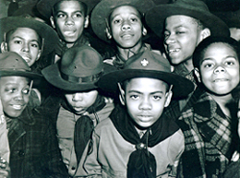
The Boy Scouts of America was well established when World War II began. As soon as war was declared, Boy Scout leaders telegraphed President Roosevelt offering “the full and whole-hearted cooperation of their organization.” In 1941, scouts operated a message service for the Office of Civilian Defense, collected aluminum and books, and planted trees. They were a natural choice for grassroots work. By 1942, there were 1,600,000 members and almost every town, city, and village had a scout troop. These clean-cut boys and young adults had knowledge about their neighborhoods and were welcomed when they approached homes and businesses (Banas, 2005).

Eager Boy Scouts get ready to distribute posters in their neighborhoods (208-LU-13K-21) Ellis, 2005
In 1942, the Office of War Information distributed posters through the scouts. They received their first assignment in October 1942 when they distributed a Columbus Day poster. Within 24 hours notice, they enlisted the help of 544 local council offices. In communities of more than 2,500 people, the scouts distributed posters in local stores every two weeks. At first, African American troops only distributed posters with African American themes. Their poster featured Dorie Miller who received the Navy Cross for heroism at Pearl Harbor. It was given out to Boy Scout troops, churches, restaurants, and benevolent organizations. In May 1943, when President Roosevelt signed the Executive Order than banned discrimination against government and defense workers, the posters received by all troops were the same (Ellis, 2005).
Troops began to integrate throughout the U.S. but many troops remained all black. By remaining segregated by choice, they provided a sense of heightened awareness in the community and illustrated unity that complemented their internal needs.
As an organization dedicated to developing morally strong and virtuous men out of boys, the Boy Scouts of America stress the importance of understanding what it means to be a Scout. When applying for an Eagle Scout Award, the highest rank in the Scouts, applicants must submit an essay along with documentation of their earned merit badges. In the essays, scouts are asked: “In your own words, describe what it would mean to you to become an Eagle Scout.” Essay lengths differ greatly from one sentence to four handwritten pages. Generally, Eagle Award applicants write about what it has meant to work several years to receive this award, and what they plan on doing after they receive it. Immediately following integration, different values and goals regarding Eagle Scout applications emerged based on race. In their responses, one white scout described opportunities to go to college and get a good job. Black scouts had a tendency to make references to the army and military service. Not necessarily saying outright that a future in the military was what they were striving for, but references like “if I get my Eagle Award it will be like being a Captain or Lieutenant in the Army, working my way toward the rank of General.”
Historically, the military has been one of the few ways black men achieved distinction and respect. Many scouts saw their fathers and uncles return from World War II and the Korean War with medals. They realized that this was their only way to eventually get into college or have a good career. The Eagle Award was another way to show their pride, dignity, and level of achievement. It was their opportunity to have an equal chance at distinction and success and inspired many to push ahead in the fight for liberty (Banas, 2005).
Many men who later became famous were members of the Boy Scouts. They include Neil Armstrong, Navy aviator, astronaut, and first man to set foot on the moon (Eagle Scout); General William Westmoreland, commander of U.S. military operations in Viet Nam (Eagle Scout); John F. Kennedy, 35th U.S. President; and Gerald Ford, 38th U.S. President (Eagle Scout) (Zeiger, 2010). In addition, Bill Gates, founder of Microsoft was a Life Scout and Senator Richard Lugar (IN) served as an Eagle Scout.
Famous African Americans who served as Boy Scouts include Hall of Fame baseball player Hank Aaron (Eagle Scout) who said that scouting was one of the greatest positive influences in his life. Marion Barry, former Mayor of Washington D.C. (1979-1991) and current city council member was an Eagle Scout. Others include Branford Marsalis, jazz musician; Richard Roundtree, actor, and Togo West, Jr. who served as Secretary of Veterans Affairs during the Clinton Administration (Famous Scouts, 2007).
Since World War I, Boy Scout alumni have served in the U.S. armed forces. Stories of scouts turned soldiers are evident in WWII, Korea, Viet Nam, the Persian Gulf, Iraq, and Afghanistan. A century after it’s founding – the Boy Scouts are thriving. Membership stands at 2.8 million youth and 1.1 million adult volunteers. Old rituals are still preserved by the scouts – games like Kick the Can, no-rules football, gathering around the campfire at night to sing songs and learning how to take responsibilities for themselves are common practices. Scouting continues to provide “hope for the future” (Zeiger, 2010).
For the Buffalo Soldiers Research Museum, our attention focuses on those who served as Boy Scouts and later served with the 28th U.S. Horse Cavalry during World War II. We met a few of these Buffalo Soldiers - Trooper Lorenzo Denson and Trooper Uell Flagg – who were proud Boy Scouts during their youth.
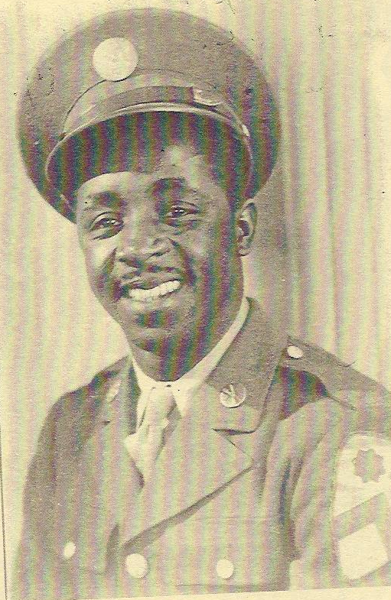
Lorenzo Denson (pictured at left) was born on May 18, 1920. He told us that Troop 55 was the largest Boy Scout troop in Cincinnati, Ohio. He said that all the members were African American. At the age of 21, he joined the Army. He told us that his days as a Boy Scout could easily translate to his military life. He was stationed in Camp Lockett, California where he learned to ride horses and attended radio school. Later, he served during World War II in Casablanca, North Africa and Naples, Italy.
In November, 1945, he returned to Cincinnati with an honorable discharge. Denson was employed with the Board of Education where he worked as a power plant operator for 37 years. Before his retirement, he had earned the top job in his department.
During this time, he continued to serve in this organization and earned an award for 25 years of “devoted and untiring work” from Troop 5[6]5 of the Boy Scouts of America (Hicks and Hicks, 1999). The adult leaders provide leadership and strengthen the program – especially those who were members during their youth.
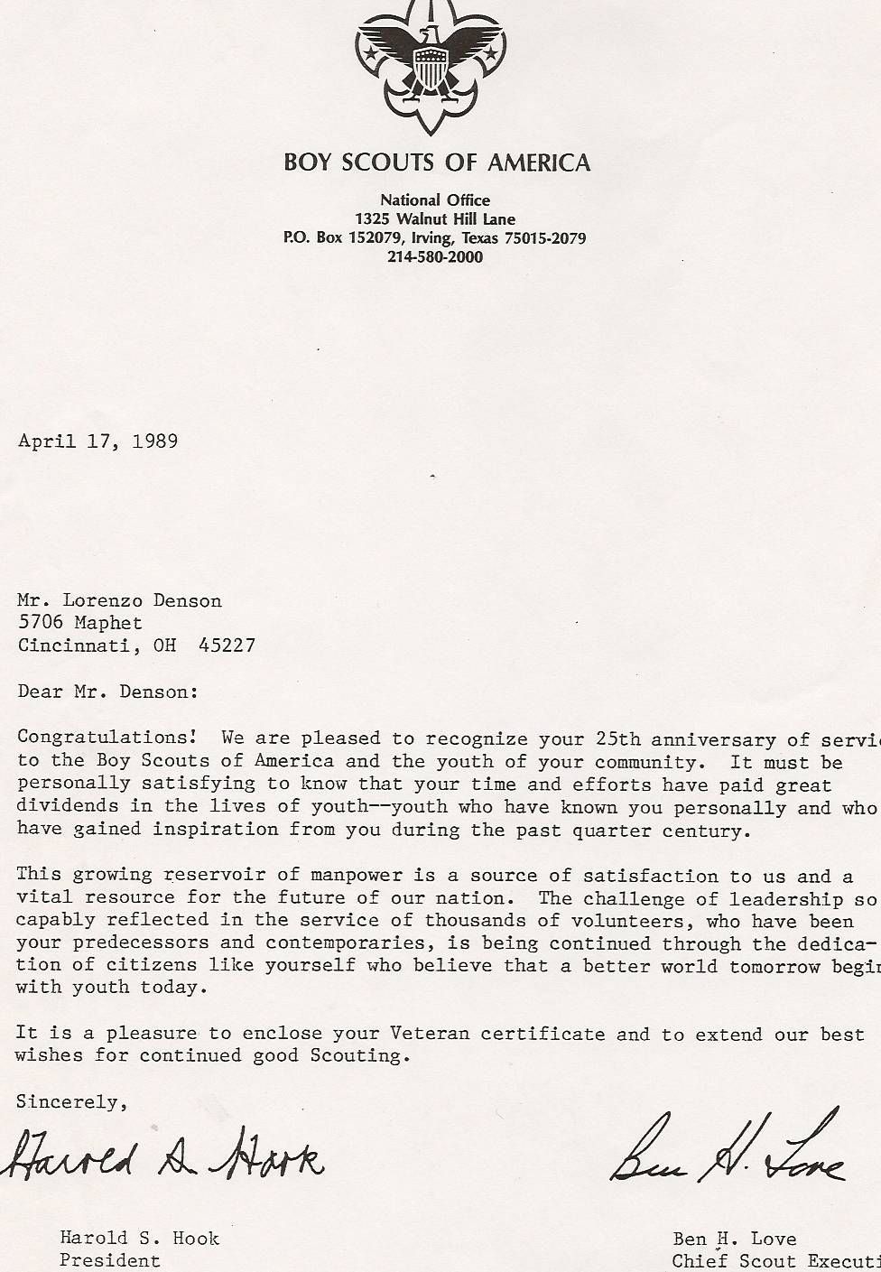

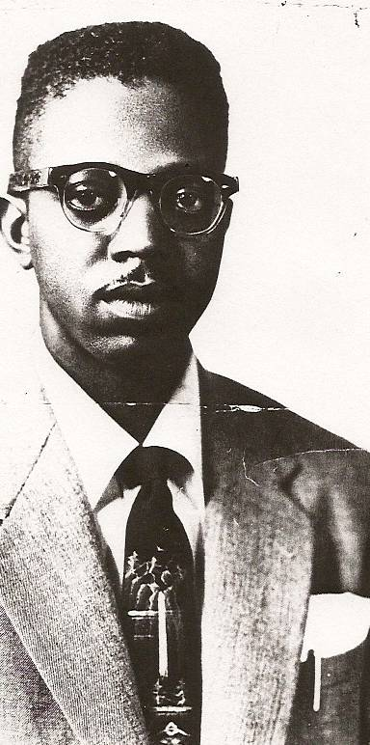
Uell Flagg (pictured at right) was also a member of Boy Scout troop #55. He stated that there were more than 300 members in his troop.” Flagg was born in Cincinnati on November 28, 1924. He grew up in the West End of the city where a large population of African Americans lived.
Flagg was a drummer during his four or five years as a member of the Boy Scouts. He earned the rank of first class. Boy Scout Troop 55 was different. He recalled:
We were chosen to march in most downtown parades. We often led the parades-all in uniform. Our Scout Master was Leo J. Hopkins who served from 1929 to 1963. He was a great man. He cared about all the boys in his troop. He was employed by a furniture store downtown. The store was located near the court house. If one of the boys in our troop got in trouble with the law, Leo would request that the boy be turned over to him. He would work with the parents and the troop to solve the problem. Our Scout Master was well respected in Cincinnati.
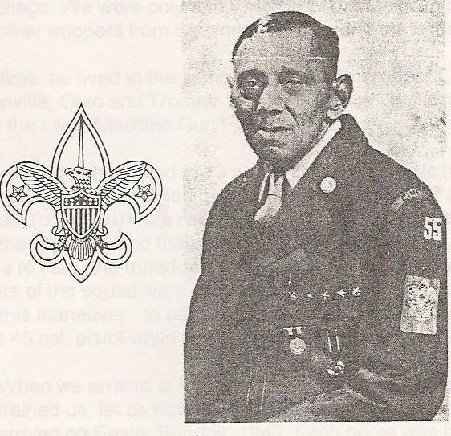
Trooper Flagg told us that when he looked back on his life, Mr. Leo J. Hopkins (pictured at left) had more of an impact on his life than anyone besides his parents. According to Flagg, he truly cared about the scouts’ well-being. The training he received as a scout made his transition from civilian life to the military easier. On March 5, 1943, Flagg volunteered to join the Army and was stationed at Camp Lockett, California for training. During World War II, he served in North Africa, Italy, France, and the Philippines. He received an honorable discharge on December 3, 1945. After working for the railroad for several years, he decided to return to military life. In the summer of 1951, he volunteered to join the Air Force where he was stationed in Korea and Japan. He was discharged on March 31, 1958 and returned to Cincinnati where he retired from the post office with 30 years of service. Flagg told us that the military worked out for him (Hicks and Hicks, 2000).
We visited with Lorenzo Denson and Uell Flagg - Boy Scouts and Buffalo Soldiers – in the spring 2006. Denson was residing in a nursing home and was not able to walk but he was positive and encouraged us to move forward with our story. Flagg rode with us to visit Denson. He was still driving and living alone in an apartment. He continued to be upbeat as he talked about his process for dialysis. On his living room table, we counted at least 15 different pill bottles but he was not discouraged or even concerned about his prognosis. He seemed very “matter-of-fact” about his medical condition and knew he had to just go along with the plan prescribed by his doctors.
Both soldiers have passed away - Lorenzo Denson (May 18, 1920 - October 3, 2006) and Uell Flagg (November 28, 1924 – August 8, 2007). Boys Scouts of America and Buffalo Soldiers – the result was a positive influence on each man’s character, citizenship and lifelong friendship.

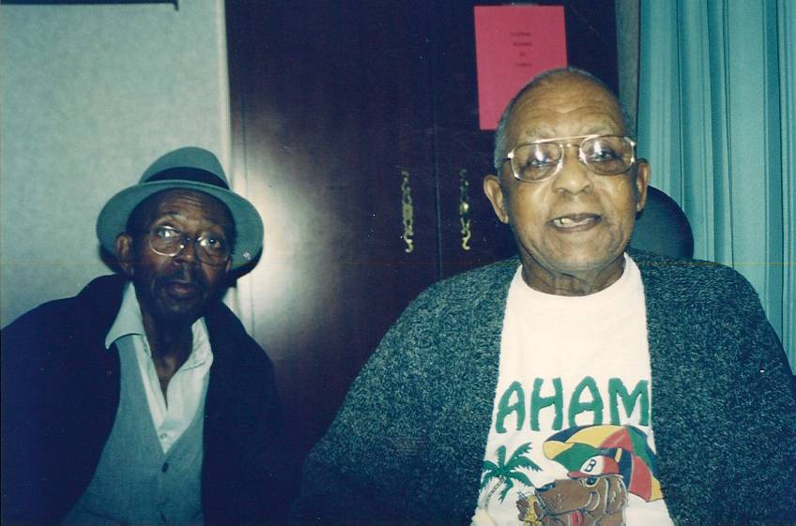
Uell Flagg and Lorenzo Denson, spring 2006

References
Banas, K. (2005). African American registry. Retrieved on February 9, 2010 from
http://www.aaregistry.com/african_american_history/2786/The_Black_Boy_Scout

Baranowski, T., Baranowski, J., Cullen, K., Demoor, C., Rittenberry, L.,
Hebert, D., and Jones, L. (2002). 5 a day achievement badge for African
American boy scouts: Pilot outcome results. Prevention Magazine, 34(3).
p. 353-363.

Ellis, R. (Summer, 2005). Getting the message out: The poster boys of world
war 2, part 2. Retrieved from
www.archives.gov/publications/prologue/2005/summer/posters-2.html

Famous Scouts - Scouts New England Web Site (2007). Retrieved on February
19, 2010 from http://sne.tripod.com/famous,htm

Hicks, G, III and Hicks, C.W. (1999). An interview with a trooper from the 28th
(horse) cavalry – Lorenzo Denson. Cincinnati, OH: Buffalo Soldiers
Association.

Hicks, G, III and Hicks, C.W. (2000). An interview with a trooper from the 28th
(horse) cavalry – Uell Flagg. Cincinnati, OH: Buffalo Soldiers
Association.

Hicks, G, III and Hicks, C.W. (2006). Our journey with the Buffalo Soldiers.
www.Xlibris.com

Zeiger, H. (February, 2010) Partners for God and Country. The American Legion
magazine, Indianapolis, IN.

