www.buffalosoldiersresearchmuseum.org
Buffalo Soldiers Research Museum Newsletter
April 2007
Volume 5 - Issue 2
Published four times each year ~ January, April, July & October

Publishers’ Comments
This year, we celebrate our fifth anniversary for publication of this Buffalo Soldiers Research Museum newsletter. When we began, our goals included sharing information with those who had never heard of the Buffalo Soldiers and distributing our research findings to readers who want to enjoy our journey.
Our five years of work have been fulfilling. There have been challenges and rewards but we know that God has given us our mission. We had the opportunity to meet World War II Buffalo Soldiers, interview them, and interact with them on a personal level. Although we are saddened when another soldier leaves us to go to Fiddler’s Green, we will continue to broaden our knowledge about them. And, we will share our findings at no cost to you.
As we move into our sixth year, we plan to expand our efforts with your help and encouragement. We invite you to submit information, photographs, articles, and other documentation related to the Buffalo Soldiers so we can share it with others. We are a not-for-profit organization and we enjoy researching the positive contributions that these men and women made throughout history. We will share your research findings, too.
We want to take a minute to thank those who have shared their military histories with us. The family of Trooper Lorenzo Denson from Cincinnati, OH (who passed away on October 3, 2006) invited us to speak at his memorial service. In the summer of 2005, the wife of Trooper Louis Garrett from Summerset KY donated his “Ike” jacket for our collection after his death. These defining moments are great examples for us. Recently, another highlight has been our communication with Trooper Ron Jones from Los Angeles, CA Chapter of the 9th and 10th (Horse) Cavalry Association. He is the son of WWII Trooper Fred Jones. He recently purchased a copy of our book and keeps in touch with us through his Chapter newsletter. We are grateful for our connections and look forward to hearing from other descendants and soldiers.

Best regards,
George and Carmon Hicks

A Few Living Buffalo Soldiers: What’s Next?

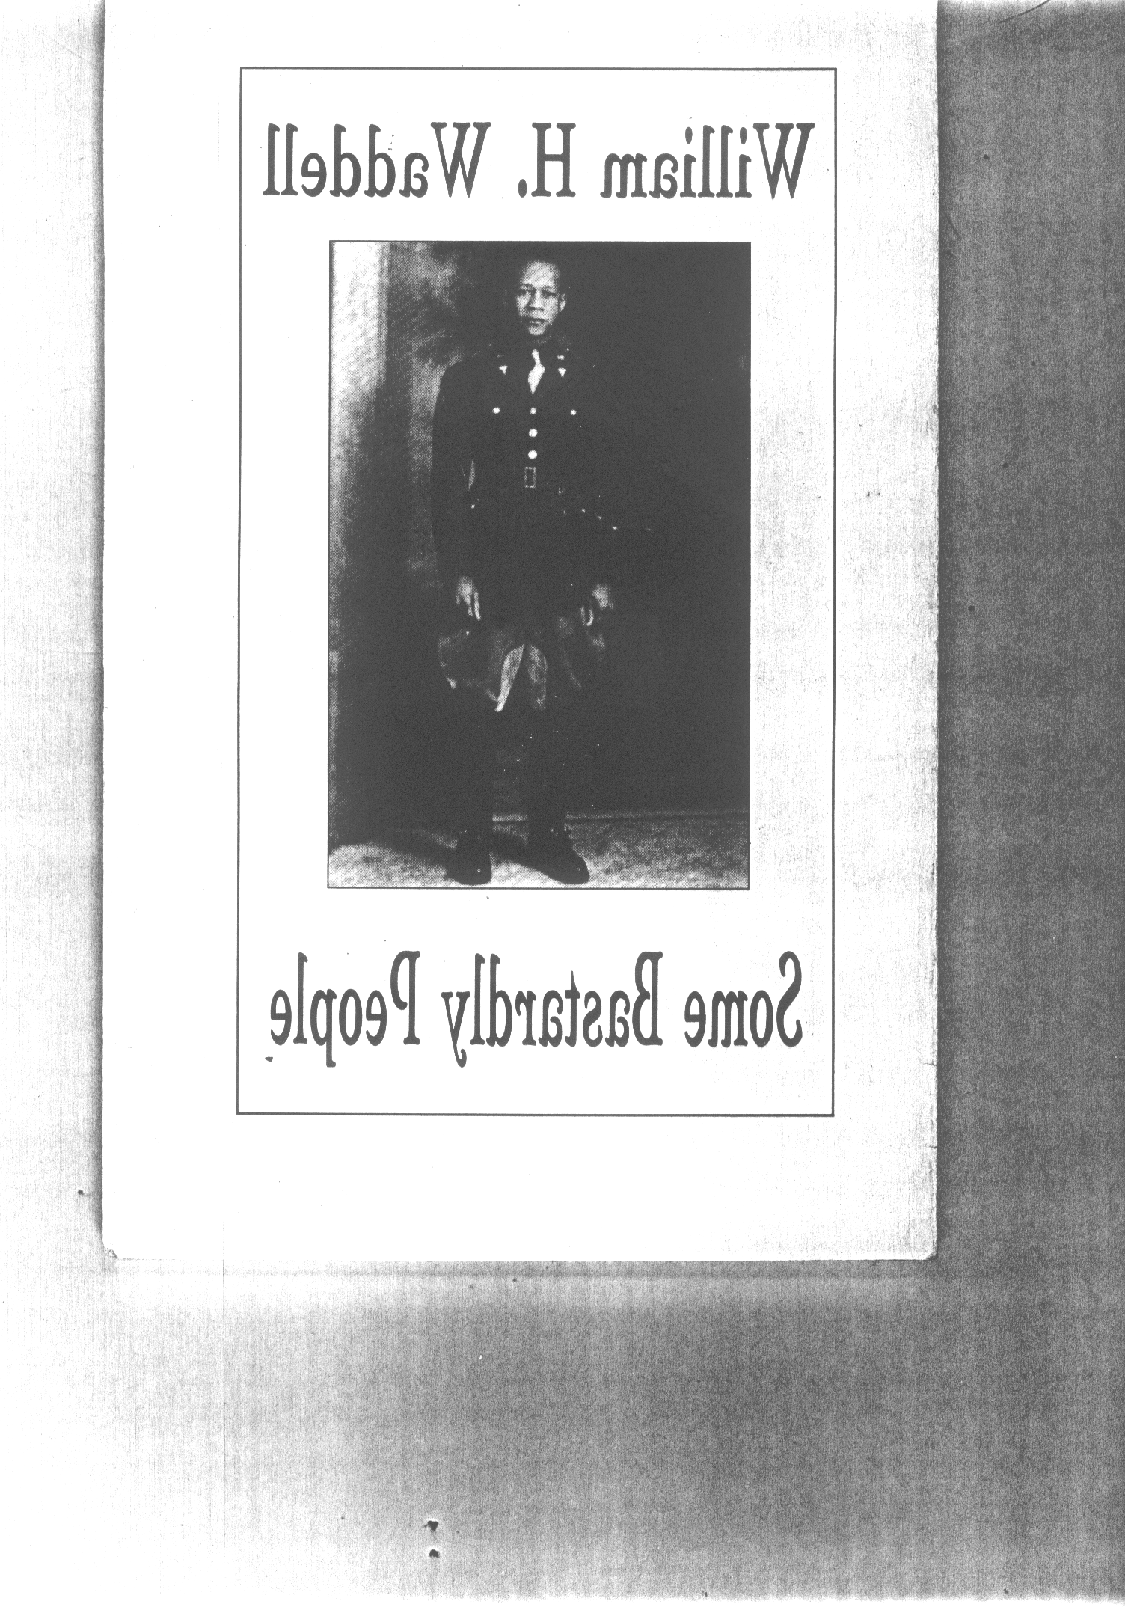
Over the past ten years, we have witnessed the passing of many who served in the U.S. Armed Forces as Buffalo Soldiers. We met and interviewed some of these soldiers and read the stories of other soldiers. Our first encounter was with troopers from Cincinnati, OH who served in World War II. These men were assigned to the 28th US Horse Cavalry, Troop C at Camp Lockett, CA near the Mexico border. They were trained by soldiers of the 10th Horse Cavalry who were stationed at Camp Lockett before the 28th was activated. A few of these troopers are living today. We have seen the passing of Troopers Fred Jones who gave his time, talents and personal resources to ensure that the story of the 28th Horse Cavalry at Camp Lockett does not get lost in history. The Mountain Historical Society has honored Trooper Jones with a bronzed stature in his image.
We interviewed Trooper William H. Waddell (pictured at right), age 92, at the 134th Annual Reunion of the 9th and 10th Horse Cavalry Association in 2000 at Kansas City. We learned about his life growing up in Virginia and his service in the 9th and 10th Horse Cavalry Regiments. He passed the Pennsylvania State Board of Veterinarian Medicine in 1935 and was the first black veterinarian in the state. Waddell enjoyed talking about his days at Tuskegee Institute (now Tuskegee University). He said that George Washington Carver gave him the opportunity to work on peanut oil therapy. Dr. Waddell wrote several books - People are the Funniest Animals (1998) published by Dorrance & Co. in Philadelphia, PA and Some Bastardly People (1995) published by McClain Printing Co. in Parsons, WV. We own a hardback edition of People are the Funniest Animals with a hand written note from Waddell that says “When you go home-tell them of us the Buffalo Soldiers.” Dr. William Waddell enjoyed his final years in Hawaii; he went to Fiddler’s Green on January 30, 2007 at the age of 98.
In the last two decades, Buffalo Soldiers have received many honors. The Buffalo Soldiers Monument was dedicated in 1992 at Fort Leavenworth, KS. In addition, on December 7, 1993 Sgt. Mark Matthews (the oldest Buffalo Soldier – born in 1894) was honored in the Oval Office at the White House. He stands to the left of President Bill Clinton in the photo. Documentaries that tell their stories, many books and countless newspaper articles are available. Many people have launched websites to share stories about these troopers. A good example is Anthony L. Powell, who has been researching and teaching their history for more than 30 years. Currently, he teaches “The Buffalo Soldier: His Time, His Life and Family 1866-1940” at San Jose State University. Powell offers a host of resources, traveling exhibits and historical artifacts to the public. For more information, visit www.portraitsinblack.com.
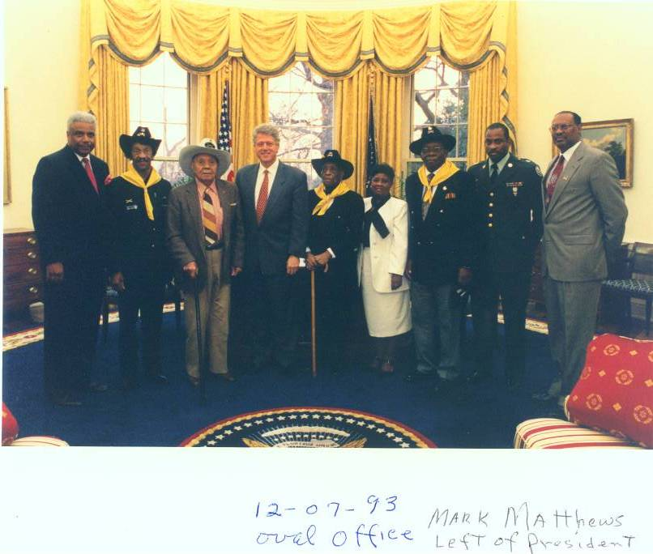

The official Army association for the horse cavalry is the 9th & 10th (Horse) Cavalry Association. This association has more than 30 chapters located across the United States. It is a not-for-profit organization with the goal to ensure the legacy of these troopers is passed on to future generations. In addition, there is a National Museum dedicated to the Buffalo Soldiers in Houston, TX.
Where do we go from here? How do we continue when there are no more living soldiers who served in the military units called Buffalo Soldiers? How do we ensure that their stories live on? Part of our mission at the Buffalo Soldiers Research Museum is to be a free repository for researchers, teachers, students and others who can utilize information we have compiled. The U.S. government is a great resource for obtaining printed information about the Buffalo Soldiers and other black soldiers who served in the military. The Superintendent of Documents, U.S. Printing Office internet bookstore has a host of information for purchase.
We, at the Buffalo Soldiers Research Museum, have witnessed first-hand artifacts such as original photographs, books and other documents that were ready to be discarded at the landfill. Trooper John Morton-Finney, a World War I Buffalo Soldier who served in the 24th Infantry Regiment, went to Fiddler’s Green with no family left to represent his interests. His only daughter passed away two years ago and his home with his personal collections was sold. The purchasers of his estate did not understand the historical value of his collection and many items were lost to the landfill. We felt lucky as we searched the dumpster and saved a few items. As we move into the future, everyone can participate in saving our history by encouraging veterans and their families to sell, donate, or place their artifacts on loan. This documentation will help researchers connect the dots and keep the legacy alive.
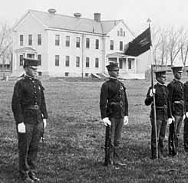
Upcoming Events
The sixth Fort Robinson History Conference will be held on April 26-28, 2007. The theme is Four-Legged Soldiers: The Horse and the Mule in the Plains Wars and Beyond. The conference includes scholarly paper presentations, tours of Fort Robinson, and several social events. One evening’s reception will feature books from the Fort Robinson Museum and many of the authors will be available to sign their books.
From Crazy Horse to the cavalry to the K-9 Corps, Fort Robinson played host to them all. The museum at Fort Robinson is located in the 1905 post headquarters building. Museum exhibits trace the history from the post's role guarding the Red Cloud Agency (1874-77) through the housing of World War II German POW's (1943-46). Among the many fascinating objects in the museum's exhibits are the only known dog kennel from the K-9 Corps of World War II, marksmanship medals earned by Caleb Benson, a Buffalo Soldier at Fort Robinson between 1902-09, and 19th century Sioux objects related to the Red Cloud Agency. More than a dozen historic structures such as the 1904 blacksmith shop, the 1908 veterinary hospital, the 1887 officers' quarters, the 1875 guardhouse and adjutant's office, and the old post cemetery are open to visitors. A museum library features materials on Fort Robinson, military, and western history for researchers. A self-guided tour book and many books on military and western history are available for purchase in the museum store. Check it out!
Click this link for details about The Fort Robinson History Conference, 2007.

Buffalo Soldiers Research Museum
P.O. Box 531187
Indianapolis, IN 46253

www.buffalosoldiersresearchmuseum.org

