www.buffalosoldiersresearchmuseum.org
Buffalo Soldiers Research Museum Newsletter
April 2006
Volume 4 - Issue 2
Published four times each year ~ January, April, July & October

First Lieutenant Vernon Baker and the
Congressional Medal of Honor

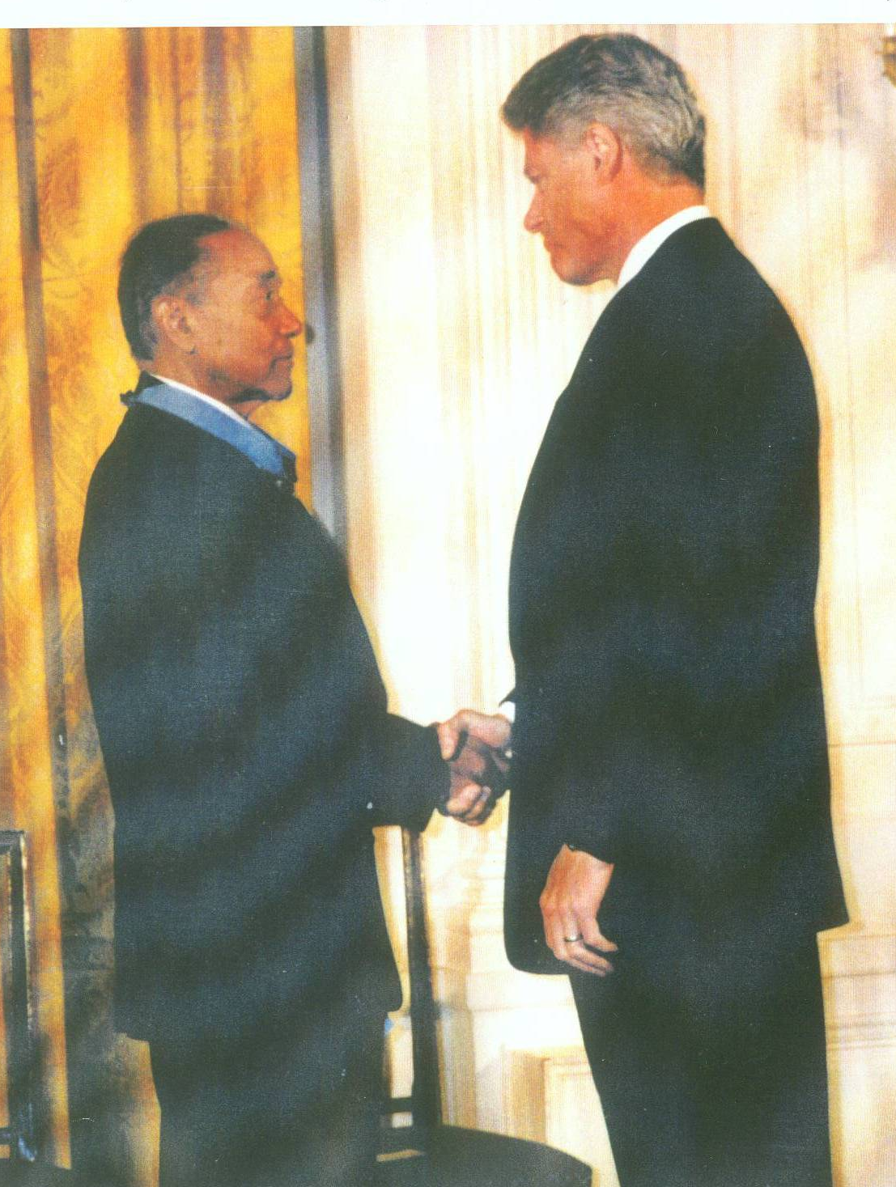
Vernon Baker was a 24 year old second lieutenant stationed near Viareggio, Italy at the time of the action for which he was cited for the Congressional Medal of Honor. He enlisted in the Army on June 26, 1941- six months before the U.S. entered World War II. He received his commission on January 11, 1943 and was assigned to the 92nd Infantry Regiment. He witnessed the American attack on the village of Sommocolonia under the direction of First Lt. John Fox. He participated in the destruction of three machine gun positions and the observation post on April 5- 6, 1945 where Fox was killed with 100 German soldiers. He helped evacuate his unit’s wounded. The next day, he led his battalion’s advance through enemy minefields and heavy fire.

On April 5, Baker wrote: Oblivious to the world around me, I shuddered and heaved…seeing the men you live with, eat with, and fight beside blown to pieces hour after hour seizes your soul and finds the places where anguish lives, no matter how artful you hide it. In July, Baker went to Viareggio on leave. One morning while walking to breakfast at the USO, the USO building exploded. He ran to the scene and helped put bodies on stretchers.

Vernon Baker and President Bill Clinton, 1997

Baker worked as an Army photographer and master sergeant when he returned to the US. He was assigned to Ft. Bragg, North Carolina, near Fayetteville where he graduated from NCO School at the top of his class. Fayetteville was segregated and full of hate. One day while walking down the street, a colonel got in Baker’s face and told him to remove the Distinguished Service Certificate ribbon. Baker refused and told him to check the record. The colonel did not bother him after apparently checking the record.

When the Korean War began in 1950, Baker went to Ft. Campbell, Kentucky and joined the 11th Airborne Division. He volunteered to go to Korea but the Army refused to send him because he had earned the DSC. He was stationed in Alaska and Ft. Huachuca, Arizona before he retired in August 1965 as First Sergeant.

In 1967, he moved to Mainz, Germany and worked for the Red Cross. He spend a year in Viet Nam (1969) before returning to Ft. Ord, California. In 1986, he moved to Idaho to putter, paint, hammer, heal and reflect. In 1994, he received a phone call from a Shaw University professor asking why no blacks in World War II had received the Medal of Honor. Baker participated in many difficult interviews and relived the details of his memories. Newspaper articles, television stories, letters from supporters, and phone calls from churches and community groups were non-stop. When Baker met President Bill Clinton on January 13, 1997, he was glad that he did not ask about the war. When the President placed the medal around his neck, Baker cried for the real heroes he left on that hill in 1945. After the ceremony, they went to Arlington National Cemetery to visit a fellow soldier’s grave.

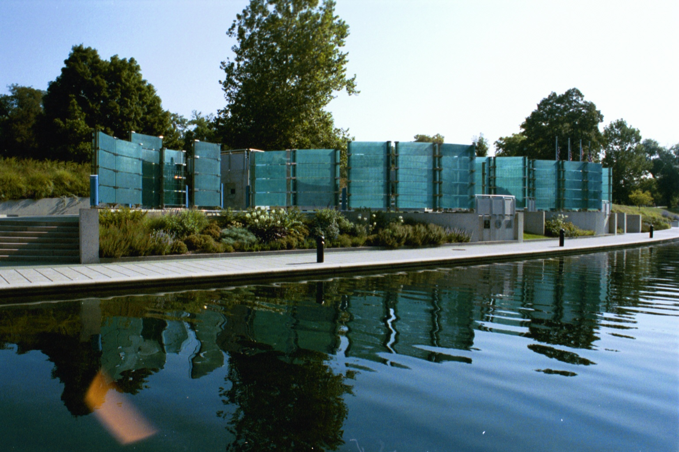
Congressional Medal of Honor Memorial, Indianapolis

On May 28, 1999 (the last Memorial Day of the century) the Medal of Honor Memorial was dedicated along the White River Canal Walk in downtown Indianapolis, Indiana. First Lieutenant Vernon J. Baker was the only living African American soldier to attend the dedication ceremony in Indianapolis. He also visited the Tillman H. Harpole American Legion Post 249 located on Dr. Martin Luther King, Jr. Street.

Luther E. Hall, from Indianapolis, was Lt. Baker’s First Sergeant during World War II. They were part of Company C, 370 Infantry in the 92nd Division. Hall donated the photograph of President Clinton and Baker to Post 249.

Research about other WWII soldiers…

The 9th and 10th Cavalry Regiments 1941 Yearbook
9th and 10th (Horse) Cavalry Association
Edited by Harold S. Cole and Franklin J. Henderson

This two-set “yearbook” includes 10th Cavalry and the Second Cavalry Division soldiers at Camp Funston-Fort Riley in 1941. The history of the 10th Cavalry and Camp Funston features photographs of soldiers, sports teams, a panoramic view of Camp Funston-Fort Riley and action photos in field service. Individual photos with names are listed.

The review of the Second Cavalry Division uses snapshots to highlight soldiers fighting in Topeka, building pontoon bridges, working in the stables, preparing meals and traveling by train. Individual photos with names and a brief history of the 9th Cavalry are included.
It’s a yearbook with many details and names.

Two-set: $45.00. Individual yearbook: $25.00. Include shipping and handling.
Contact www.buffalosoldiersresearchmuseum to purchase.

More information about the
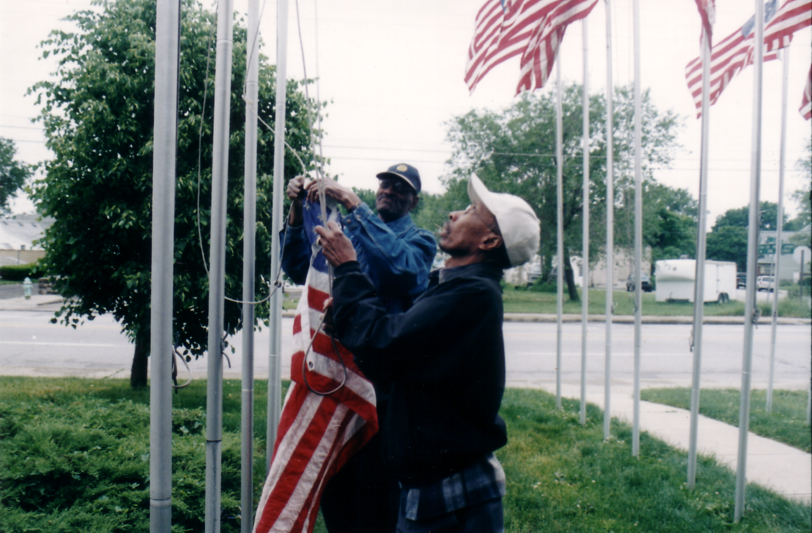
CONGRESSIONAL MEDAL OF HONOR

The Congressional Medal of Honor is the nation’s pre-eminent award for military valor. It was the first decoration officially authorized badge of honor by President Abraham Lincoln on July 12, 1862. This honor was presented to enlisted soldiers whose conspicuous gallantry was above and beyond the call of duty. Each soldier’s deed was one of personal bravery or self-sacrifice - an action that distinguished the individual above his comrades. David Bentley and Virgil Hampton

The flagpoles at American Legion Post 249 represent each African American who was awarded the Congressional Medal of Honor. This project, called the “Avenue of the Stars” was established by Chaplain Edward Harris. These flags are raised on special occasions during the year.

Our Journey with the Buffalo Soldiers is AVAILABLE!

Our Journey with the Buffalo Soldiers written by George and Carmon Hicks is a compilation of historical research, travel adventures, family histories, and personal stories. African American military units were established in 1866 and these Army soldiers had much to prove. They earned the name “Buffalo Soldiers” from Indians who held their fighting spirit in high regard. They served in the Indian Wars, the Spanish-American War, World War I and World War II. Stories of racial prejudice are peppered throughout their history. During World War II, the Army mechanized their equipment and these units were disbanded.
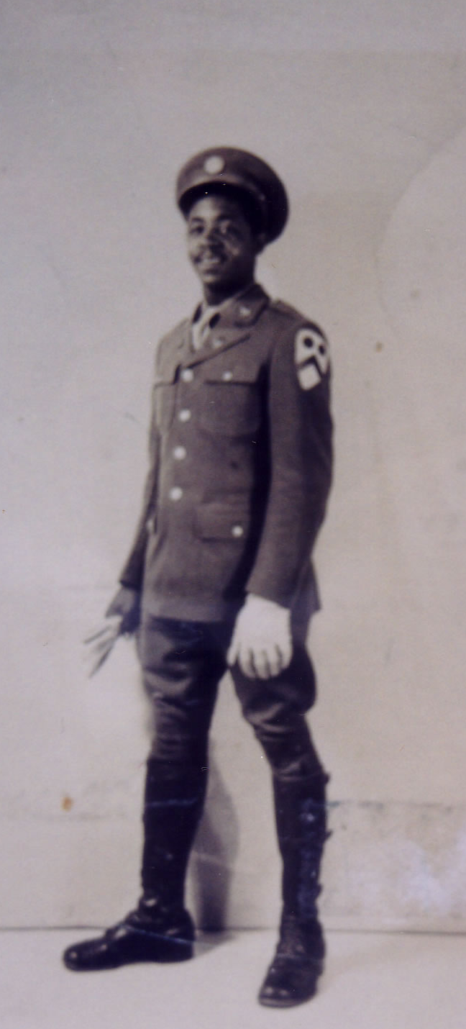
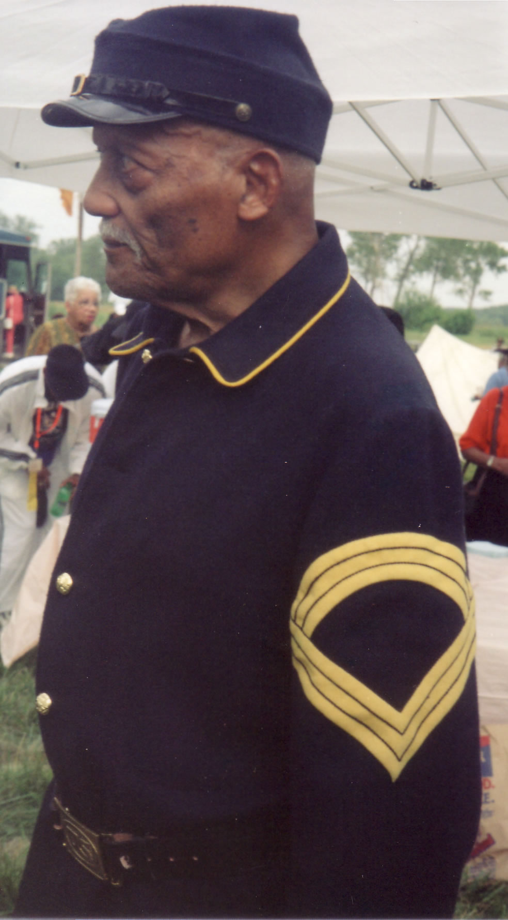
Our journey focuses on the stories of World War II soldiers but a historical perspective is provided to lay the foundation for these stories. Information about Lt. Henry O. Flipper, the first African American graduate from the West Point Military Academy and other historical military figures are included. Each story is situated by its location and is part of the “journey.” The stories about the World War II soldiers are personal. Some described how they were afraid of horses but learned to ride, clean and feed them. Other stories describe their train travel across the US, living on a ship going across the Atlantic Ocean, surviving an accident in a jeep during the European Theater, leaving the Army and joining the Air Force, and life events after World War II. Many men returned “home” and took advantage of the GI Bill or settled into stable government jobs.

Photographs and interviews with Buffalo Soldiers who attended the anniversary reunions of the Buffalo Soldiers Association add a special touch. City by city and fort by fort – personal stories are connected to each location. From Thomasville, GA to Portland, OR the Buffalo Soldiers have many stories to share.
.
(Photos: Lorenzo Denson 1940s - above and Fred D. Jones, 2001 - right)

To purchase
Our Journey with the Buffalo Soldiers
visit www.xlibris.com.

Xlibris Corporation
436 Walnut Street
Philadelphia, PA 19106
1.888.795.4274 or 215.923.4686

www.buffalosoldiersresearchmuseum.org

