www.buffalosoldiersresearchmuseum.org
Buffalo Soldiers Research Museum Newsletter
April 2005
Volume 3 - Issue 2
Published four times each year ~ January, April, July & October

Notes

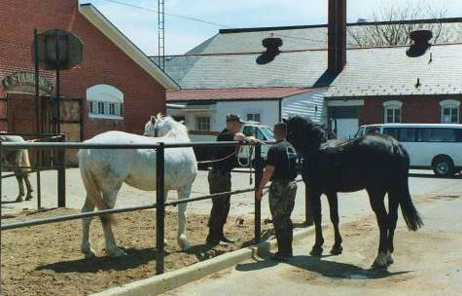
Our research about the Buffalo Soldiers sometimes leads us back to places we know and love. We recently visited Washington DC and walked the grounds at Ft. Myer where the Buffalo Soldiers were stationed in the 1890s. As a reward for their hard service during the Pine Ridge Campaign, they were the first black regiment assigned to a location east of the Mississippi River. To learn more, read Fort Myer Buffalo Soldiers published by the Equal Opportunity Office at Fort Myer or our book - Our Journey with the Buffalo Soldiers.

We enjoyed brunch near Eastern Market and visited the College Park campus bookstore at the University of Maryland. Traffic woes on I-395 and riding through Anacostia reminded us of life in the city. Our favorite bookstore on DuPont Circle, Howard University students strolling down Georgia Ave., and people-watching while we ate a few crabs on the wharf brought back fond memories. And speaking of food… our gourmet dinner at B. Smith’s in Union Station reminded us of the upscale soulfulness that DC wears with pride.

We made a special trip to get a glimpse of the cherry blossoms on the National Mall. It was getting late in the season but the blooms were still light pink. Every breeze brought more of them to the ground but the effects reminded us of gently falling snow. A visit to the nation’s capital in the spring brings many informative encounters. We will focus on a few. Enjoy!

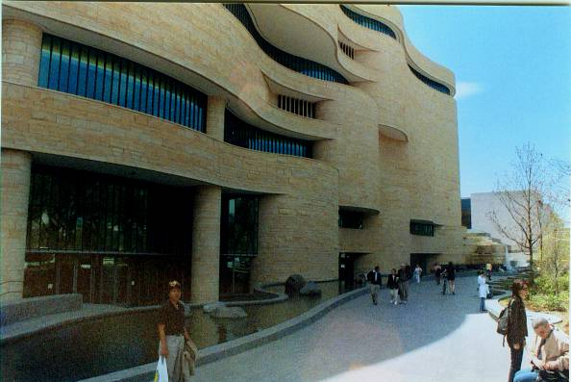
Trooper George Hicks, III
Carmon Weaver Hicks
BSRM researchers

Landmark Travel Guide

The Smithsonian’s National Museum of the American Indian opened in September 2004. (Carmon standing in front of the building.)
Rock formations, the masonry work and five-story curvilinear shape of the 250,000 square foot building add to the golden-hued limestone exterior. In keeping with the American Indian tradition, the building faces the rising run and is surrounded by wetlands, meadowlands, and croplands. Natural colors are used throughout the museum to reflect the Native people.

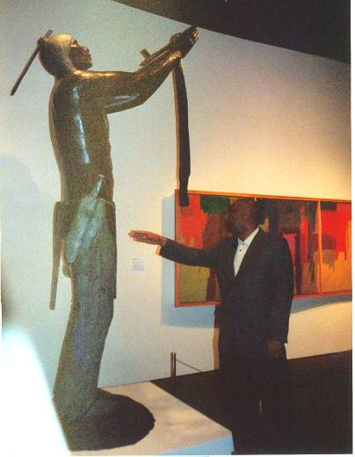
We toured several permanent exhibits. “Our Lives” presents 21st century life for the 24 Native communities from around the world who collaborated with the museum designers to tell their stories in their own words. “Our Peoples” focused on historical events told from an American Indian point of view. Videotaped stories illustrated the false interpretation of the American Indians’ history. For example, children’s stories about cowboys and Indians only provide the perspective of the cowboy.

This museum offers a collection of about 8,000 artifacts from North, Central and South America. We noticed areas on every floor with large drawers where tourists pulled them open to look at peace medals, beadwork, gold objects, arrowheads, figurines or turquoise jewelry.

The Changing Exhibition – Native Modernism: The Art of George Morrison and Allan Houser inspired us to watch a video about Morrison after we enjoyed the huge sculptures and art designs that these two American Indians created. (George in photo pointing toward the Indian sculpture.)

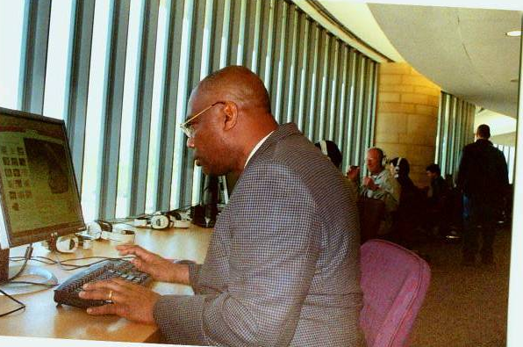
We were drawn to the Resource Center where a wall of computers lined the wall. We were able to send specific bibliographies and other interactive information to our home email accounts. Websites with detailed information were easy to obtain and the staff in the center were enthusiastic helpers.

And last but not least, the bookstore (located in the gift shop) had categorized the American Indian tribes by location. It was easy to locate books about specific communities; we found several provocative titles about Black Seminole Indians in Florida and the Plains Indians who were noted for giving the Buffalo Soldiers their nickname.

Reflections
On a scale from 1 to 10, this museum earns a rating of 10. Its architecture reflects the essence of the people and the gallery exhibits are well planned to offer excellent learning opportunities for the novice and the seasoned museum-goers. The curators did not pull any punches in telling the true history of western expansion. Some museums choose not to include information about the Indians Wars; some say they don’t want to upset the Indian community. Perhaps they don’t want to face the truth! We salute the Smithsonian’s Museum of the American Indian on the National Mall for taking a stand and offering the people’s viewpoint.

How can we teach the history of the United States and not tell the whole story? Students have been taught that the American Indians were savages but the reality is that they wanted to preserve their land, their culture, and their families. Who killed off the buffalo which was the livelihood for the land? Who took the land and placed the Indians on reservations in remote locations? Tell the whole story and don’t leave out over 30 years of wars. Let the people tell their stories and let the ball fall where it may!

African American & American Indian Books

Brooks, J. F. (2002). Confounding the Color Line: The Indian-Black Experience in North America. Lincoln: University of Nebraska Press.

Forbes, J. D. (1993). Africans and Native Americans: The Language of Race and the Evolution of Red-Black People (Second ed.). Chicago: University of Illinois Press.

Gallay, A. (2002). Indian Slave Trade: The Rise of the English Empire in the American South, 1670-1717. New Haven: Yale University Press.

Guinn, J. (2002). Our Land Before We Die: The Proud Story of the Seminole Negro. New York: Penguin Putnam, Inc.

Katz, W. L. (1986). Black Indians: A Hidden Heritage. New York: Simon & Schuster Children's Publishing Division.

Littlefield, J., Daniel F. (2001). Africans and Seminoles From Removal to
Emancipation. Jackson: University Press of Mississippi.

May, K. (1996). African Americans and Native Americans in the Creek and Cherokee Nations, 1830's to 1920's: Collison and Collusion. New York: Garland Publishing, Inc.

Nash, G. B. (1974). Red, White, and Black: The Peoples of Early America. 2nd ed.). Englewood Cliffs, NJ: Prentice-Hall, Inc.

Porter, K. W. (1996). Black Seminoles: History of a Freedom-Seeking People. Gainesville: University Press of Florida.

Rose, J. M., & Eichholz, A. (2003). Black Genesis: A Resource Book for African-American Genealogy (2nd ed.). Baltimore: Genealogical Publishing Co., Inc.

American Indian Websites

I" Is Not for Indian
http://www.nativeculture.com/lisamitten/ailabib.htm
American Indian Higher Education Consortium Virtual Library
http://www.aihecvl.org/
American Indian Radio on Satellite
http://www.airos.org/
Carol Hurst's Children's Literature Site
http://www.carolhurst.com/subjects/nativeamericans.html
Creek Indian Researcher
http://freepages.genealogy.rootsweb.com/~texlance/main.htm

Home of the Cherokee Archival Project
http://www.rootsweb.com/~cherokee/

Indianz.com
http://indianz.com/
Native American Authors
http://ipl.si.umich.edu/div/natam/
Native Languages of the Americas: American Indian Books and Literature
http://www.native-languages.org/books.htm

POWERFUL NATIVE-AMERICAN IMAGES REVEALED IN PICTURE BOOKS
http://www.scils.rutgers.edu/~kvander/ChildrenLit/native.html
Teacher Vision: Native American Resources
http://www.teachervision.fen.com/page/6648.html
For more information, contact the
Buffalo Soldiers Research Museum
P.O. Box 531187
Indianapolis, IN 46253

www.buffalosoldiersresearchmuseum.org

