Buffalo Soldiers Research Museum Newsletter
April 2004
Volume 2 - Issue 2
Published four times each year ~ January, April, July & October

Black History Month 2004

J.O.Y. Program

The J.O.Y. Program (Just Older Youth) located in the Meridian Presbyterian Church at 4701 N. Central Ave. sponsored a Buffalo Soldiers’ presentation on February 3, 2004. The evening began with a hearty dinner of fried chicken, broccoli, macaroni and cheese, rolls, and pie. Then, George Hicks, III detailed the rich history of the Buffalo Soldiers. Stories about Buffalo Soldiers included:

- Lt. Henry O. Flipper who was the first black graduate from the U.S. Military Academy at West Point in 1877.
- Baseball player Jackie Robinson who served in the U.S. Army in the 1940s
- Hoosier Buffalo Soldier John Morton-Finney who served in World War I and earned 11 academic degrees. The IPS Education Center was re-named for him in 2000.

These stories helped the teens see how military service can lead to a variety of options for career and life goals. In addition, Carmon Weaver Hicks shared information about the only documented female Buffalo Soldier - Cathy Williams - who served proudly for nearly two years before her secret about her gender was discovered.

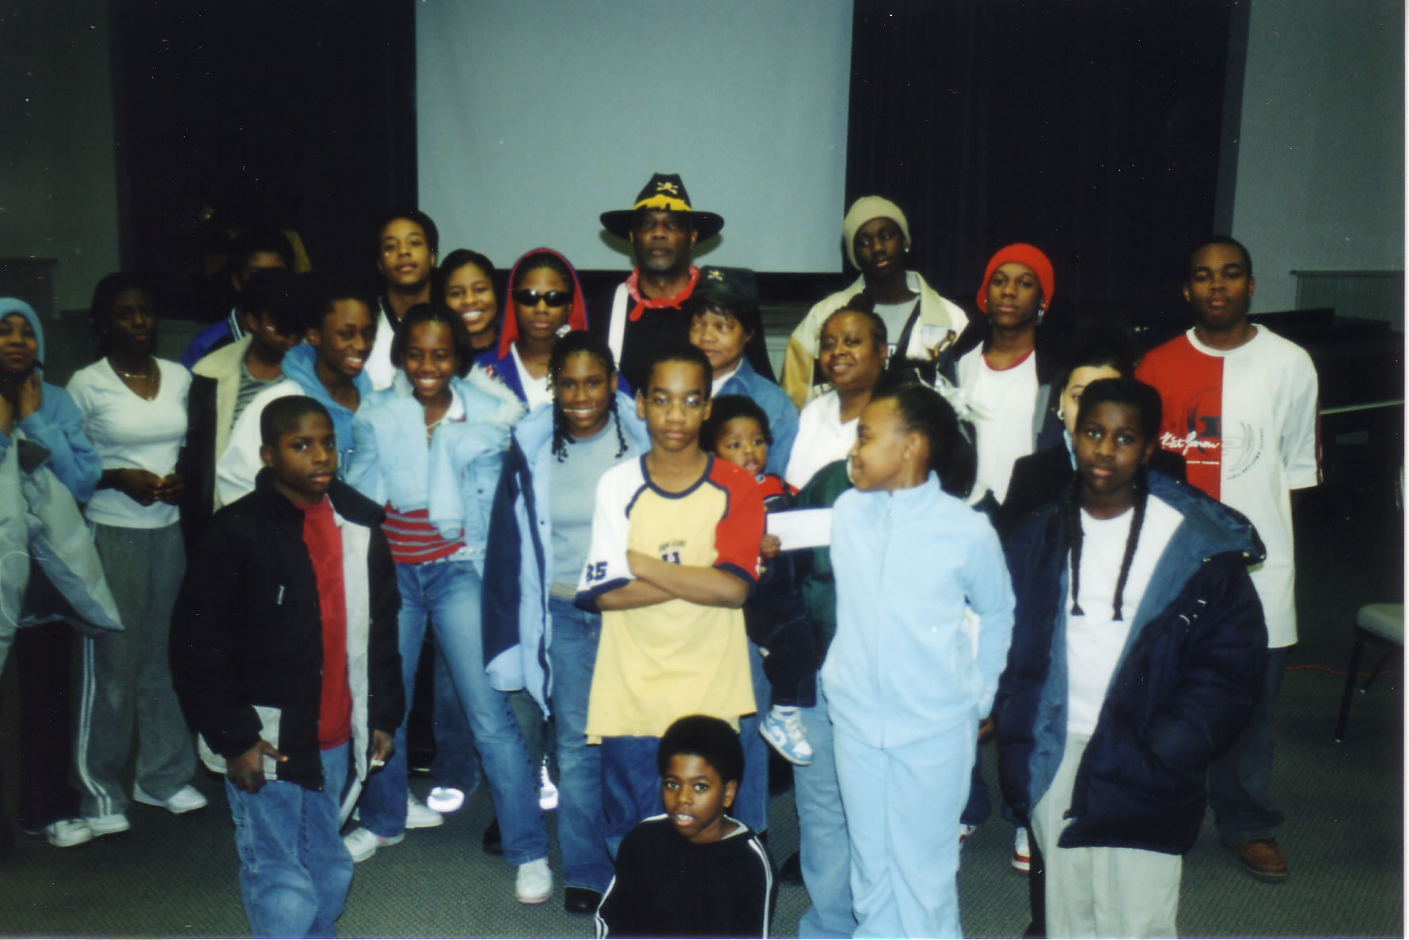
Group Photo taken by Alonzo Smiley

The J.O.Y. Program reaches out to the community by providing activities designed to motivate and stimulate the teenage mind. Teens (ages 14-19) learn employment and life skills and can participate in service learning, peer mentoring, and recreational activities.
The teens were engaged throughout the program; they asked and answered many questions about the Buffalo Soldiers. By hearing the challenges and successes of these soldiers, these teens can realize their own dreams regardless of the difficulties. Pictured on the previous page are many of the J.O.Y. Program participants with George Hicks, III.

Many thanks to Julia Hayden, Associate Director of the J.O.Y. Program, for inviting us to share information about the Buffalo Soldiers. And, a special thanks to Brenda Walls who brought participants from the Kaleidoscope Youth Center to see the presentation. She was responsible for recommending our presentation to the J.O.Y. Program and continues to be a big promoter of our educational services.

Meet the Artists XVI Gala Reception

On February 7, 2004 from 5:00-6:00 pm, the Buffalo Soldiers’ slide show was presented to more than 75 people in the auditorium at the Glendale Branch of the Indianapolis-Marion County Public Library. Participants learned how our research efforts continue to bring us closer to “home.” George shared information about his hometown connections to Lt. Henry O. Flipper and Lt. Jackie Robinson who were born in southern Georgia near George’s hometown. Then, he ventured to Indianapolis to find heroes in Carmon’s hometown – John Morton-Finney, Doc Burton and Charles Patterson – Buffalo Soldiers who served during the Spanish American War or World War I.

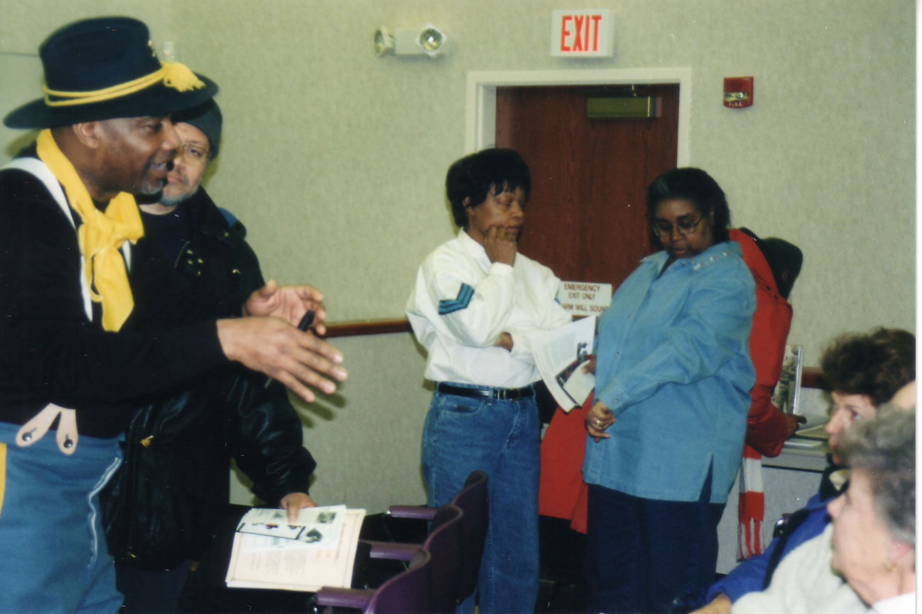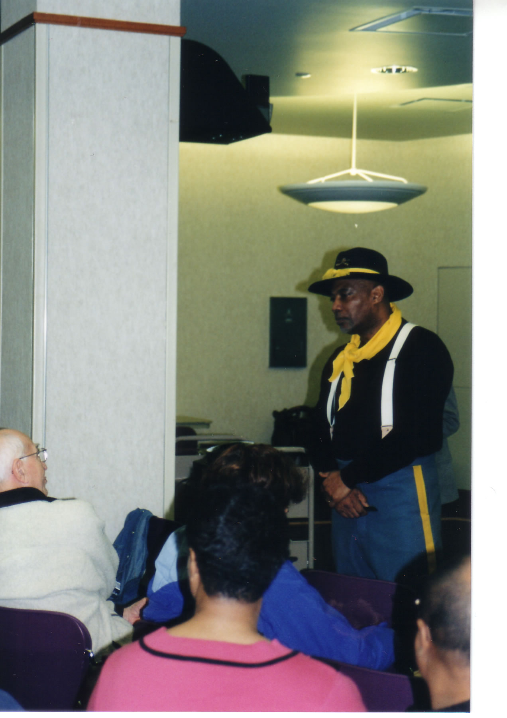
George Hicks, Carmon Weaver Hicks and Susie Henderson George speaking to the audience

The Buffalo Soldiers presentation was the opening event that included 12 visual artists, four book authors and seven performing artists. Art exhibits were displayed throughout the mall as well as book signings, a children’s theater, a fashion show, and music by the band Art of Musiq. The mall was filled with young and old who learned about history and creative arts.

Thanks to Anthony Radford who works for the Indianapolis-Marion County Public Library but wanted a forum to show his artwork and the artwork of other young black artists. He developed the program 15 years ago and has successfully grown the program to include national and local artists. Each year, Anthony and the library’s African American Committee create a different forum to educate the public during the month of February.
Ivy Tech State College

Ivy Tech State College - North Meridian Campus offered a series of events during black history month. Free Town Village presented “A Day in the Life of Rev. Samuel Strong,” Father Boniface Hardin from Martin University performed as Frederick Douglass, David Lewis from the Clerk of Courts lectured and State Representative Honorable William Crawford was the featured guest speaker. A panel presentation was also given and students, faculty and staff could attend the play “Jitney” at the Indiana Repertory Theater for a discounted price.

On February 16, 2004, George Hicks offered a “teaser” about the Buffalo Soldiers for the students, faculty and staff. This teaser was a video about the Vision Quest Buffalo Soldiers who are “troubled” youth who have turned their lives around after participating in this program. The photo below shows the Vision Quest youth during a parade in Cincinnati after the riots in 2001 that began a boycott in downtown Cincinnati that is still in effect today.

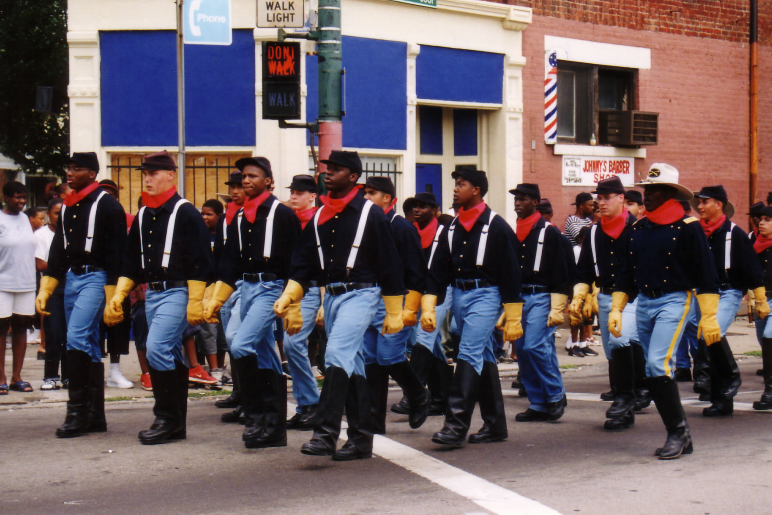
Vision Quest Buffalo Soldiers – Cincinnati, 2001

On February 25, 2004, George returned to Ivy Tech to share a historical slide presentation with the audience. The participants learned about the Buffalo Soldiers and asked specific questions. After the slide show, everyone enjoyed a meal prepared by the Culinary Arts program. The conversation continued as faculty and students had time to digest the new information with their lunch. Business cards were exchanged and relationships were cultivated that will keep the Buffalo Soldiers’ stories alive.

Thanks to Carman Lenear (President of Black Students United), Doris McDougal, Sherris Johnson, and other members of the committee who worked together to make the program possible. A poster-size announcement advertised the events and reminded students of upcoming events during the month. During each campus visit, there were many enthusiastic people who wanted to learn more about our history. It was a welcoming environment that encouraged our efforts to tell the stories of the Buffalo Soldiers.

Upcoming Events

Buffalo Soldiers Research Project
Camp Lockett, California Research
San Diego, CA
March 31- April 4, 2004
Museum curator and researcher will study the history of the 28th (Horse) Cavalry during World War II.

National World War II Memorial Dedication
May 27-30, 2004
The official dedication ceremony will be held on Saturday, May 29 at 2:00 pm
The National Mall
Washington DC
For more information visit - www.wwiimemorial.com

138th Annual Reunion - 9th and 10 (Horse) Cavalry Association
July 28-31, 2004
Ft. Sill, Oklahoma
For more information about the reunion, contact Troopers W. Sam and Mae Samuels at (580) 248-2614.
For information about lodging, contact Michelle Flanagan at (580) 442- 1977

WANTED
Information on the soldiers and descendants from these U.S. Army units

Buffalo Soldiers Units

9th U.S. Horse Cavalry Regiment established July 28, 1866
10th U.S. Horse Cavalry Regiment established July 28, 1866
38th U.S. Infantry Regiment established July 28, 1866
39th U.S. Infantry Regiment established July 28, 1866
40th U.S. infantry Regiment established July 28, 1866
41st U.S. infantry Regiment established July 28, 1866
24th U.S. Infantry Regiment established 1869
25th U.S. Infantry Regiment established 1869
27th U.S. Horse Cavalry Regiment established 1943
28th U.S. Horse Cavalry Regiment established 1943

Contact
Trooper George Hicks, III
317.388-8126
buffalosoldiersresearchmuseum@org

