www.buffalosoldiersresearchmuseum.org
Buffalo Soldiers Research Museum Newsletter
January 2011
Volume 9 - Issue 1
Published four times each year ~ January, April, July & October

Association for African American Historical Research and Preservation (AAHRP) 2011 Biennial Black History Conference
Saturday, February 5, 2011

The Association for African American Historical Research and Preservation (AAAHRP) Biennial Black History 2011 conference will be held at the Northwest African American Museum (NAAM), 2300 S. Massachusetts St., Seattle, Washington (pictured below).

The Museum’s exhibits and programs feature the visual arts, music, crafts, literature and history of African Americans in the Northwest. NAAM focuses on African Americans whose route to the new world was through slavery as well as recent immigrants arriving from places such as Somalia, Sudan and Ethiopia. The Museum is not a collecting institution at this time; it relies on individual, regional and national collections in the development of its own exhibits and programs.

The AAAHRP locates, collects, preserves, and disseminates historical and genealogical information related to African Americans. This organization supports activities that increase public awareness and understanding of African American history.



The AAAHRP conference theme is – Black History at Home and Abroad: Uncovering the Past. The day-long conference will offer presenters who will share their insights about a variety of historical concepts. Presentations range from the treatment of blacks in Germany during WWII, black women in history, black US marshals, African and Latino cultures, and many biographies to a workshop on identifying photographs from 1826-1948. We will present - Collecting World War II Buffalo Soldiers Oral Histories. Our focus is on collection and preservation strategies and our experiences working with these soldiers and their families (see picture on next page).

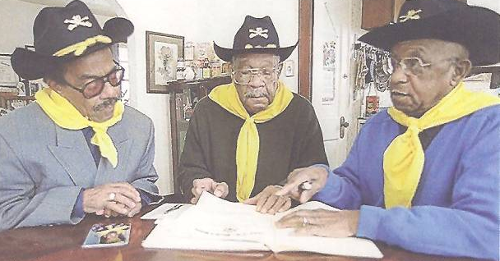

World War II Buffalo Soldiers
William Snow, Linwood Greene, Jr. and Lorenzo Denson

A Book Review –
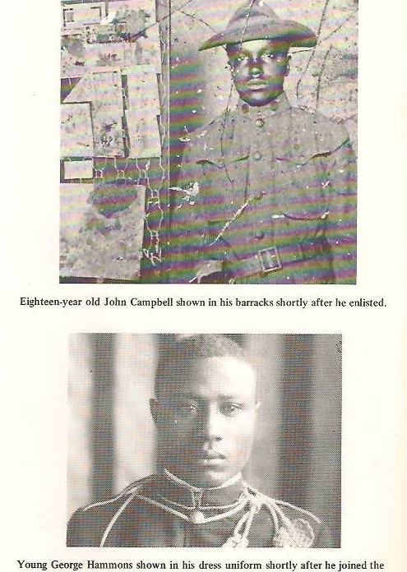
Black Heritage in Arizona
by Richard E. Harris
1977

I like to find books that are local to an area. This small booklet of 54-pages is a first edition, published by the Phoenix Urban League. In the Introduction, Harris tells the reader to expect a condensed history of blacks in Arizona beginning in 1863. He offers documentation of their contributions. Chapter headings include Estevanico, seekers of gold, black cowboys Buffalo Soldiers, and first families.

My focus is the Buffalo Soldier chapter (of course). It was a delight to see “new” photos of soldiers! The section entitled – Arizona Had It’s ‘Old Soldiers’ - tells the stories of Staff Sergeant John P. Campbell and Sergeant George Hammons (pictured at right). Note the caption for Young George Hammons… shortly after he joined the 9th Cavalry.

In 1909, John P. Campbell attempted to enlist but was told to wait until he was 18 years old. Two years later, he returned to Jefferson Barracks, MO to sign on for a 33-year military career. He was stationed with the 9th Cavalry at Ft. Huachuca, AZ in 1912 where he was assigned to border patrol and to pay the troops. There were days of bandits and renegades and many of the troops were scattered at the outposts.

World War I took Campbell to France where John J. Pershing was commander in chief. For most of the war, General Pershing did not have black troops serve in combat. The French loves the black soldiers and called them “Blue Devils.” Campbell retired in 1945 at Portland, OR.

Sergeant George Hammons recalled an experience as a 10th Cavalryman in a border skirmish against some of Pancho Villa’s men. “They had much smaller horses than ours… but when we came up on them, the shooting started. We got one of them, I think… Then we stopped chasing them. We watched while they came back to pick up their victim. Anyway, we didn’t feel like it was our war. We had to go along for the ride, you know.”

Wow! The perspective of a black man during the Indian Wars matches current thinking. Some things have not changed…

A Book Review –
A Guide to Hopi Katsina Dolls
by Kent McManus
Rio Nuevo Publishers, Tucson, AZ - 2000

A visit to the Heard Museum in Phoenix sparked my interest in Katsina dolls. On display was Barry Goldwater’s collection of more than 400 Katsina dolls. He started collecting when he was a Boy Scout and they were beautiful. Each doll individually represented different concepts from clowns to warriors. Some were sitting, some were standing, and a few were lying down. The carvings and art work were precise and feathers adorned many dolls.
I needed to explore this history and meaning of these dolls so Kent McManus’ book was a must-have.

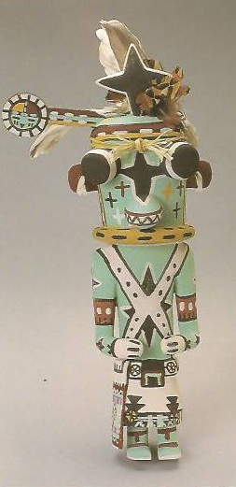
The Hopi (translated as a person who behaves in a polite and peaceful way) are a communal farming people. More than 9,000 Hopi live on a 1.5 million acre reservation in northwestern Arizona. Rainfall is scarce and the growing season is short but they have developed hardy strains of corn, beans, and squash that is cultivated in sand dunes. The Hopi believe that their best efforts for survival depend on maintaining proper relationships with inhabitants in the spiritual realm – leading to the katsinam (plural).

Early representations of katsinam date back to as early as the 1100s. Americans first appeared in Hopi territory in the 1830s and began arriving in large numbers when the United States took control of New Mexico in 1846. The Americans appreciated the art and artifacts of the Hopi culture but they did not want to sell their Katsina dolls to outsiders. But over time, they realized this was a good way to share their culture, earn money, and trade credit.

The katsinam are considered “Cloud People” because they can take on cloud form. They are the spiritual embodiment of Hopi ancestors and serve as intermediaries between Hopi people and heir deities. Katsinam hear the prayers of the faithful and convey those supplications to the gods who respond with blessings in the form of rain, bountiful harvests, and plentiful game animals.

Pictured at right-Sakwaho’te (Blue Hoote) by Clark Tenakhongva. He appears at many dances sometimes as an uncle to the other katsinam.

Katsina dolls serve as a means by which outsiders may better understand and appreciate Hopi culture and spiritual values. Hopi artists strive to create realistic and lifelike renditions of katsinam so collectors can honor an aspect of Hopi culture.

Hopi ceremonial life involves a complex group of activities throughout the year. Each village celebrates katsina season on a different schedule, with a variety of clans and societies that perform specific dances. Certain katsinam appear in every village while others may appear on one or two mesas. There are more than 300 katsinam.

The Hopi ceremonial year begins in November. This is where the ritual cycle is determined for the year and secret rites are performed. Only those who have been initiated into one of the societies may participate.
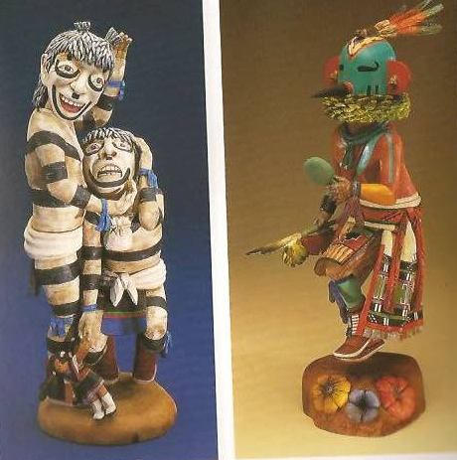
Unfortunately, when tourists are present, the role of Wuyaqqoto (the guard) becomes more real than symbolic. Many tourists forget they are guests and behave as though katsina dances are colorful shows staged for them rather than sacred, celebratory rituals. Wuyaqqoto has been known to force some of the disruptive visitors into compliance. Guests who are privileged to observe katsina rituals are prohibited from taking photos or recordings of any kind. Violators have had their camera and recording equipment confiscated, and in some cases, destroyed.

Pictured at left -Tsutskut (clowns, plural of Tsuku) by Robert Albert and To’tsa or tootsa (Hummingbird Katsina) by Brendan Kayquoptewa. Appearing at night the hummingbird helps plants bloom.

The meaning of some of the Katsina dolls include:
Bear – represents great power to cure the sick
Buffalo – most powerful among katsina dolls. Can kill evil thoughts, great spiritual protector
Morning Singer – appears on roof tops and sings songs to wake the village
Mudhead – well known katsina dolls, acts as clown
Snake dancer – sends message with the snake to ask God to bring rain
Sunface – represents warmth, shelter for the old, bright future, and playfulness for the young.

Buffalo Soldiers Research Museum
P.O. Box 531187
Indianapolis, IN 46253
www.buffalosoldiersresearchmuseum.org

