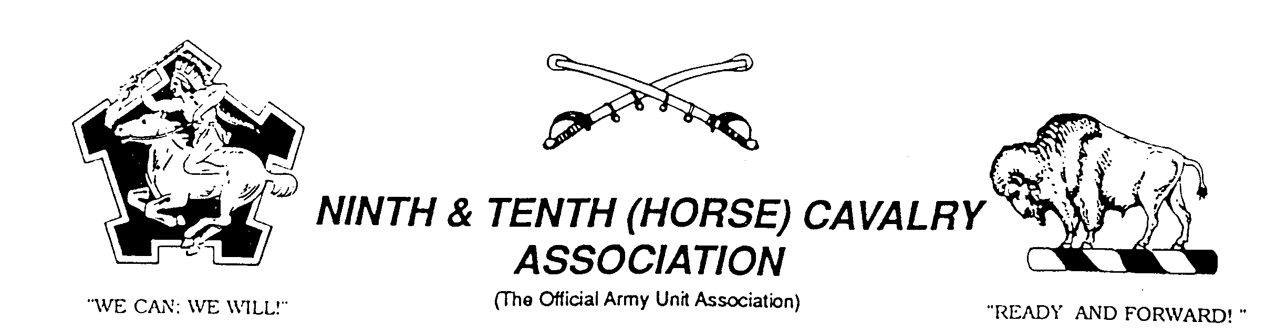

BUFFALO SOLDIERS
DR. JOHN MORTON-FINNEY CHAPTER
Indianapolis, IN

The 9th and 10th (Horse) Cavalry Association is a non-profit 501(c) (3) organization with more than 30 chapters worldwide. Each chapter has flexibility to design programs to achieve the goals of the Association. The Indianapolis Chapter will focus on education with the assistance of technology. Our primary mission is to keep the legacy of the Buffalo Soldiers alive.

The Chapter is named to honor Trooper John Morton-Finney, a World War I Buffalo Soldier, educator, and attorney. Dr. Morton-Finney was fluent in six languages and held 11 academic degrees. He earned his fourth bachelor’s degree when he was 75 years old. One motto that he coined was “It’s Such a Pleasure to Learn.” In 1998, he died in Indianapolis at the age of 108 years.

Goals

- Promote scholarship by encouraging youth and adults to study American history. This may include the development of think tanks, discussion forums, exhibits, and presentations about the Buffalo Soldiers and related topics.

- Provide on-line resources (www.buffalosoldiersresearchmuseum.org) to assist with historical research.

- Encourage African Americans to seek training in museum studies. This acquired knowledge will advance the perseverance of ancestral histories via documents, photographs, books, furniture, artwork, and other intellectual properties.

- Establish onsite location to house collections of books, periodicals, CDs/videos/DVDs, and other artifacts. This will encourage scholarly hands-on research.
9th and 10th (Horse) Cavalry Association
Dr. John Morton-Finney Chapter
Post Box 531187
Indianapolis, Indiana 46253-1187
georgehicks@comcast.net

